FEAS Faculty Reports
David Yancey
Revised: April 21, 2020

(1) Student Evaluation Reports

SPCI Overall Evaluation Summary

The overall report is a summary of question 13 from SPCI student evaluations, which correspond to the overall course evaluation. SPCI evaluations were first introduced in Spring 2013. Prior to that, SPOT/SUSSAI evaluations were used. The scales used for SPOT/SUSSAI were somewhat different that those used for SPCI. In the overall report, the evaluation counts are summarized on a single page.

Each record in the report constitutes an “evaluation order”. An order is a collection of evaluations for which statistical counts are computed. Depending on the order request, multiple course sections may be combined in an order, and even multiple courses may be combined in an order. When multiple course numbers are involved in an order, they will be listed in the report. By policy, evaluations with an enrollment count under 5 are not reported.

By default, semesters disrupted by COVID-19 are excluded from the report. An option is provided in the report selection dialog to override this behavior and include all semesters within the reporting period. The dialog with default selection options is illustrated below.

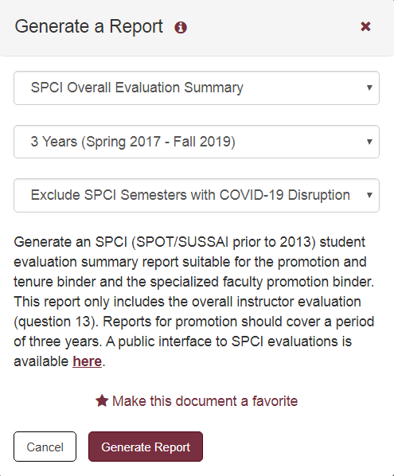

SPCI Evaluation - 13 Questions

The detailed SPCI report is a summary of student course evaluation questions 1 through 13, with one page per course evaluation. Information for this report is only available since Fall 2013. As with the overall SPCI report, semesters disrupted by COVID-19 are excluded from this report. An option is provided to override this behavior and include all semesters within the reporting period.

(2) Teaching Summary Reports

Teaching Summary Report

This report is a one page summary of course sections taught. Columns for this report include semester, course number, credit hours, course name, course type, and number enrolled. There are several variants of the teaching report which include additional information. Each teaching summary report displays the "Manage Report Data" button on the report selection dialog, which is described below. Among other things, the manage report data function includes an option to update downloaded FSU course information.

Teaching Summary w/Effort

This report adds a "Percent of Effort" column to the teaching summary report, described above. This information is obtained from FACET Actual Effort information which is prepared for the Board of Govenors. The availability of this information commonly lags the completion of a semester by a few months. Among other things, the "Manage Report Data" button includes options to update Percent of Effort from FACET and to manually enter or update effort information for reporting purposes.

Extended Teaching Report

This report adds student credit hours (SCH) to the teaching summary report. In addition, this report provides a summary count of course sections by course type, overall SPCI course evaluations, course grade distributions, and a summary of student research supervision.

By default, the SPCI course evaluation summary will exclude semesters disrupted by COVID-19. An option is provided in the report selection dialog to override this behavior to include all semesters within the reporting period.

Teaching Summary - Custom Report

The teaching summary custom report displays any available teaching summary report templates. Once a template is selected by clicking the associated radio button, the "Generate Report" button is displayed; click that button to generate a report using the report options specified for that template.

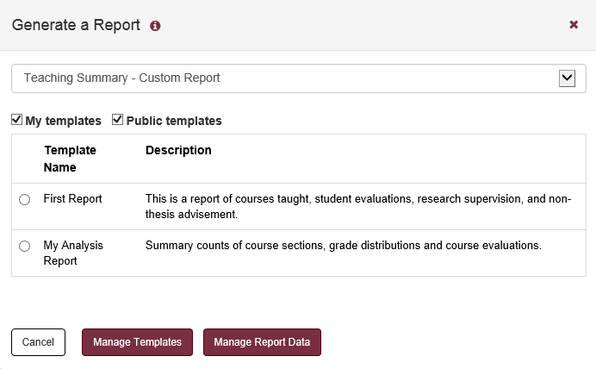

Click the "Manage Templates" button to edit or create new teaching report templates. The following page is initially displayed.

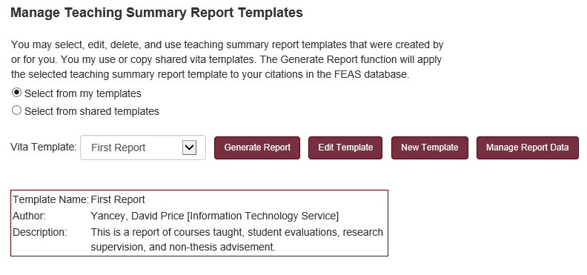

The following form is displayed when editing or creating a new teaching summary template.

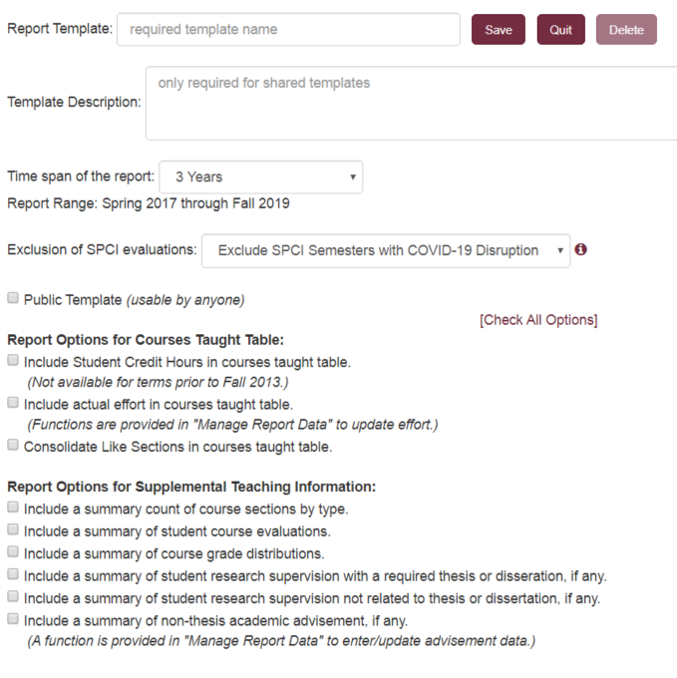

Depending on the reporting options selected, the custom teaching summary report may contain five sections of information:

- Summary of Courses Taught.
The contents of this table may be altered by the report options and the report date range. Course information is obtained from courses downloaded from Student Central (which may be manually modified if necessary). If no report options are selected, this is the only table included in the report.
- Summary Count of Course Sections.
This is a summary count of the selected course sections categorized by course type. The various course types are described below in the discussion of the “Review/Edit Downloaded Courses” section.
- Summary of SPCI Course Evaluations.
Course evaluation information as collected and provided by the Office of Distance Learning. This is a summary of overall instructor evaluations, generally referred to as question 13. Course evaluations with fewer than 5 respondents are not displayed. Semesters disrupted by COVID-19 may be excluded from the report, dependent on the SPCI display option selected.
- Course Grade Distribution.
A distribution of grades by course. Grades with a plus/minus are consolidated to the letter grade. Course sections are combined if that option was selected for the courses taught table.
- Summary of Student Research Supervision with a Required Thesis or Dissertation.
This is a summary count of doctoral, masters, and bachelors committees taken from the teaching section of the CV. These are intended to count research supervision with a required thesis or dissertation. This section will not be displayed if no data is found in this CV category.
- Summary of Student Research Supervision Not a Part of a Thesis or Dissertation.
This is a summary count of doctoral, masters, and bachelor students that were cited in the “Supervision of Student Research Not Related to Thesis or Dissertation” category of the CV. This section will not be displayed if no data is found in this CV category.
- Summary of Non-Thesis and Non-Dissertation Academic Advisees.
This is count of academic advisees by year as specifically entered for this report. This information is entered using the “Review/Edit Non-Thesis Academic Advisement” function described below. This section will not be displayed if no data is found for the reported period.

Manage Report Data

The "Manage Report Data" button is displayed on the report selection dialog; when clicked, it will present a menu of functions that manage data used in the teaching summary reports. The menu is illustrated below.

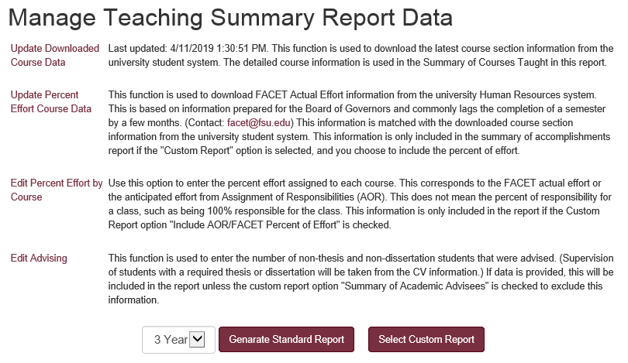

(3) Grade Distribution Summary Reports

Grade Distribution Report

This report function reports grade distributions as obtained from Student Central system. This version of the report combines +/- grades; thus, B+, B, and B- would be reported as Bs. In this report, like sections are grouped with the same course number and section title. No information entered in the faculty CV is used in the preparation of the grade distribution report.

Grade Distribution Report with +/- Grades

This report function reports grade distributions as obtained from Student Central system. All +/- grades are reported. In this report, like sections are not combined. No information entered in the faculty CV is used in the preparation of the grade distribution report.

(4) Research Summary Reports

Research Summary Report

The basic research summary report provides a summary count of citations and citation contributors by citation category and by year. Citations with a status of Accepted, Contracted, Pending, and Submitted are excluded from this count. Each research summary report displays the "Manage Report Data" button on the report selection dialog, which is described below. Among other things, the manage report data function includes an option to update the tags which identify the contributor type applied to research citations.

Research Summary - Custom Report

The research summary custom report displays any available research summary report templates. Once a template is selected by clicking the associated radio button, the "Generate Report" button is displayed; click that button to generate a report using the report options specified for that template.

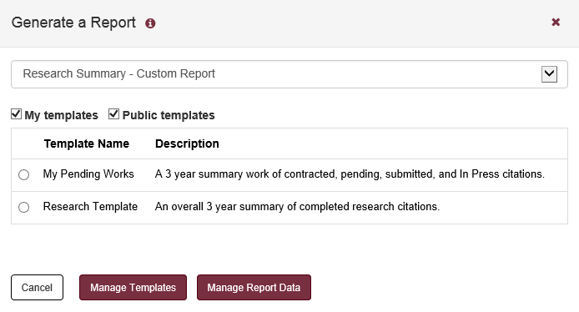

Click the "Manage Templates" button to edit or create new teaching report templates. The following page is initially displayed.

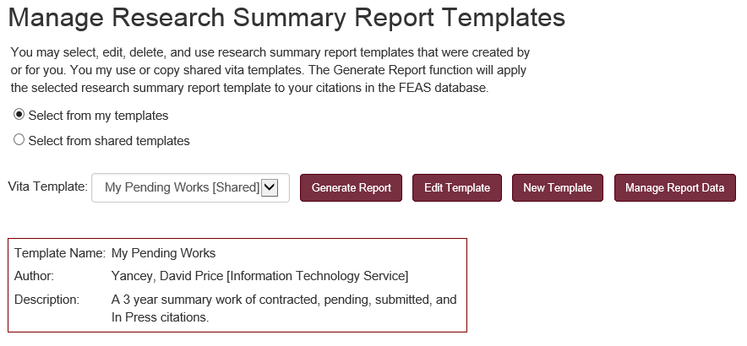

The following form is displayed when editing or creating a new research report template.

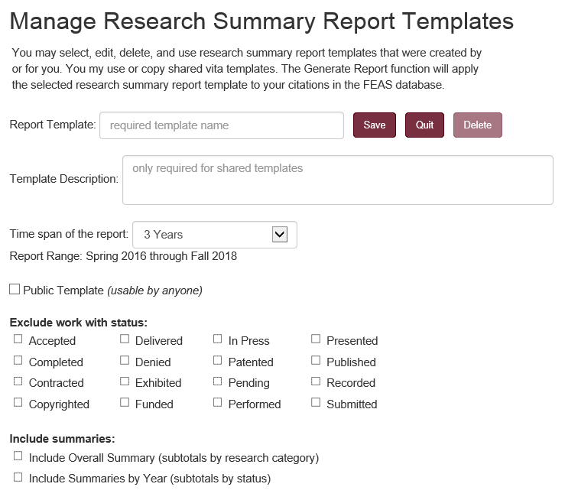

Among other things, the research summary report presents summary counts of the lead contributor for each research item included in the analysis. For example, a part of the display would include such information as:

Research and Original Creative Work  Summarized by Category | Total | Lead Contributor
Research and Original Creative Work  Summarized by Category | Total | Self | UG  Student | Mast  Student | Doc  Student | Prof  Student | Post Doc | Colleague
Invited Journal Articles Published | 2 |  | 1 |  |  |  |  | 1
Refereed Journal Articles In Press | 2 | 1 |  |  |  | 1
Refereed Journal Articles Published | 6 | 3 |  |  | 1 |  |  | 2
Nonrefereed Books Published | 2 | 2
Refereed Book Chapters In Press | 1 | 1
Refereed Book Chapters Published | 1 | 1
Nonrefereed Reports Published | 3 | 2 |  |  |  |  |  | 1
Publications Total | 17 | 10 | 1 |  | 1 | 1 |  | 4

In addition, the report includes information on the number of collaborations. In this report, collaborations are the count of authors on publications other than the faculty member him/herself.

Research and Original Creative Work  Summarized by Category | Number of Collaborations
Research and Original Creative Work  Summarized by Category | With UG  Student | With Mast  Student | With Doc  Student | With Prof  Student | With  Post Doc | With  Colleagues
Invited Journal Articles Published |  |  |  |  |  | 3
Refereed Journal Articles In Press | 1 | 1 | 1 | 1 |  | 1
Refereed Journal Articles Published | 3 |  | 4 |  | 1 | 7
Nonrefereed Books Published | 1 |  |  |  |  | 2
Refereed Book Chapters In Press |  |  |  |  |  | 1
Refereed Book Chapters Published | 1 | 1 | 1 | 1 | 1 | 1
Nonrefereed Reports Published | 1 | 1 | 1 | 1 | 1 | 6
Publications Total | 7 | 3 | 7 | 3 | 3 | 21

By default, the first name in the author list is assumed to be the lead contributor. In addition, the faculty member is identified from the list by matching the default name used for the faculty member. If the name is not matched, the name is assumed to be a colleague.

Research Citation Contributor Tagging

The "Manage Report Data" button is displayed on the report selection dialog; when clicked, it will present a menu of functions that manage data used in the report. This section describes the research citation tagging function.

When entering or editing citations in FEAS, any of the contributors may be tagged as the lead and contributors may be identified as a student, post-doc, colleague, or a group. This information may be used in characterizing research collaboration.

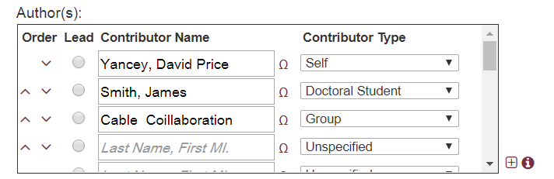

The contributor tagging function is provided as a means to review contributor tags and edit them. The initial display for this function is illustrated below.

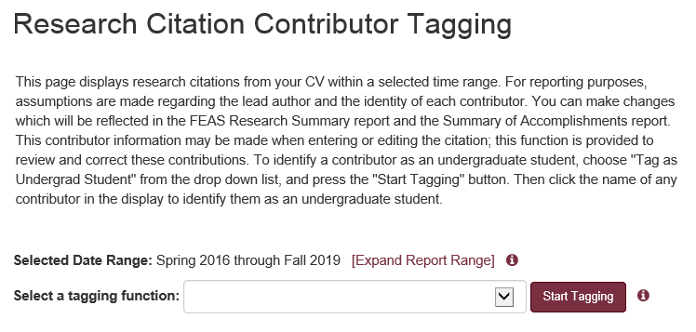

From the display, select a tagging function (e.g.: Tag as Doctoral Student) and click "Start Tagging". The “selected date range” specifies the range of citations included in the display. This range could be expanded, to include a wider range of citations for tagging.

The “Select a tagging function” is a drop down menu which is used to specify the type of tagging display presented. Options include:
- Tag as Faculty Member (Self)
- Tag as Colleague
- Tag as Undergrad Student
- Tag as Master's Student
- Tag as Doctoral Student
- Tag as Professional Student (e.g.: Law, Medicine)
- Tag as Post-Doc
- Tag as Group
- Tag as Lead Contributor

After making a tagging function selection, a list of citations are displayed. By clicking a contributor name, their tag will be changed accordingly.

(5) Summary of Accomplishment Reports

Summary of Accomplishments - Standard

The Summary of Accomplishments report combines elements from the Teaching Summary Report, the Research Summary Report, and the Custom CV for a 1 to 3 calendar year report. The standard version of this report includes a summary of courses taught, a summary of course sections, a summary of SPCI overall course evaluations, course grade distribution, summary of student supervision, summary of academic advisees, a summary of grant contract activity, a summary of research citation counts, as well as research and service citations within the reporting period. This is correspondent to the custom SOAR report with no data exclusions.

By default, the SPCI course evaluation summary will exclude semesters disrupted by COVID-19. An option is provided in the report selection dialog to override this behavior to include all semesters within the reporting period.

The SOAR report selection dialog also displays the "Manage Report Data" button, which is described below. Among other things, the manage report data function includes options to review and update research citation contributor tags, refresh downloaded FSU course information, update academic advising, and provide supplimental information that may appear in the report.

Summary of Accomplishments - Custom Report

The summary of accomplishments custom report selection dialog displays any available SOAR templates. Once a template is selected by clicking the associated radio button, the "Generate Report" button is displayed; click that button to generate a report using the report options specified for that template.

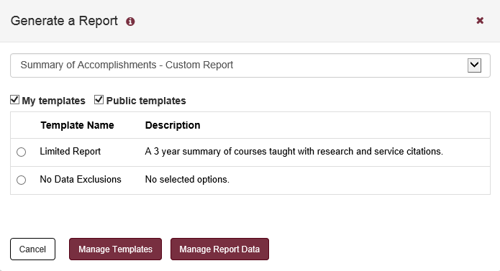

Click the "Manage Templates" button to edit or create new teaching report templates. The following page is initially displayed.

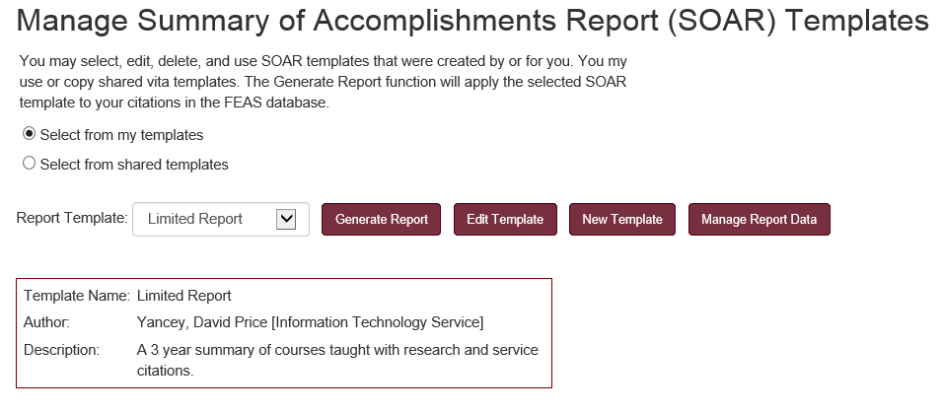

The following form is displayed when editing or creating a new summary of accomplishments report template.

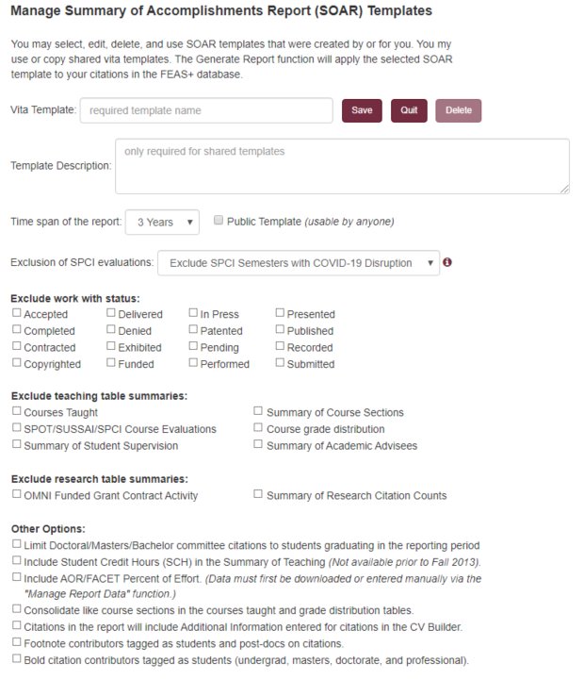

When a template is saved, it records the current checkbox settings for the custom report. If the “Public Template” is checked, then all FEAS users may select the template from the list of available templates. Otherwise, the template is private to the person that created the template. Only the person that created the template (or his/her delegate) may edit or delete the template.

Manage Report Data

The "Manage Report Data" button is displayed on the report selection dialog; when clicked, it will present a menu of functions that manage data used in the summary of accomplishment reports. The menu is illustrated below.

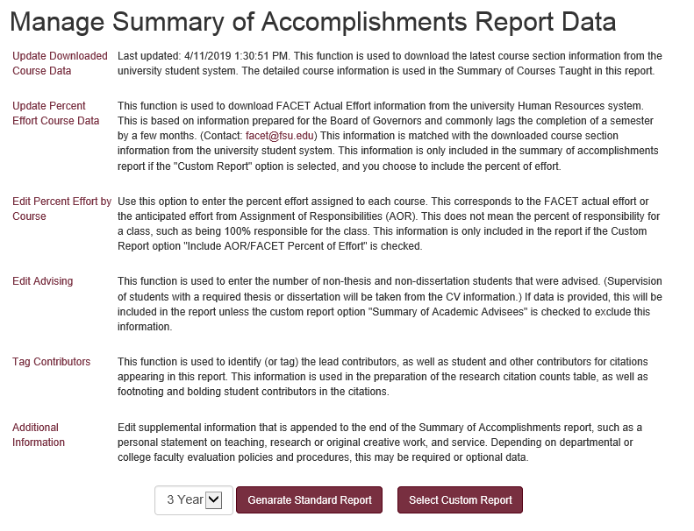

Functions include the download of updated course data from Student Central and update AOR/FACET percent effort for courses. The Edit Percent Effort by Course presents a table of courses in which the percent effort may be reviewed or updated. This information is automatically updated by the “Update Percent Effort Course Data”. Changes may be made here for purposes of FEAS reporting, but these changes will not update the FACET information source.

The Edit Advising table references the same data entered for the Teaching Summary report. In this report, the non-thesis advising numbers are limited to the selected reporting period. The Tag Contributors function is like that provided in the Research Summary Report. Contributors tagged in that report will appear here. Tagging may also be performed when entering or editing research citations.

The additional information function provides a free form textbox in which a summary statement may be entered which will appear at the end of the report. This statement is specific to the calendar year of the report and this information is not used in any other reports.

The Annual Summary of Accomplishments report includes:
- A custom version of the faculty member’s CV. In this variant, general information comes at the end and excludes address, professional experience, current membership, and expertise. In the teaching section, teaching summary tables replace the list of courses taught.
- Teaching Summary Tables. These tables are like those generated for the Teaching Summary Report.
- Research Summary Table. This table is like the annual summary table generated for the Research Summary Report. This table includes all research, regardless of status for the selected calendar year.
- Additional Information. This optional section is provided to append supplemental information to the report, such as a personal statement on teaching, research, and service.

(6) Teaching Award Reports

Teaching Award Course Cover Sheet

This report function pulls student grade distribution information directly from the Student Central system and SPCI course evaluations which are managed by the Office of Distance Learning. This report merges grade distribution information with overall course evaluations. No information from the faculty CV is used in the preparation of these teaching award reports.

When this report type is selected from the report selection dialog, the second dropdown list will display a list of candidate courses within a three year period as well as an option for a summary of evaluations, as illustrated below.

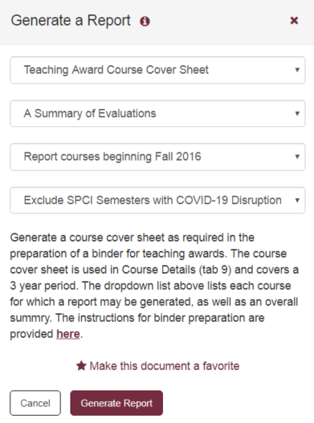

All courses within the reporting period are included in the list. Those courses without associated student evaluations are indicated as such. If no evaluations are available for the course, that information will be blank in the report.

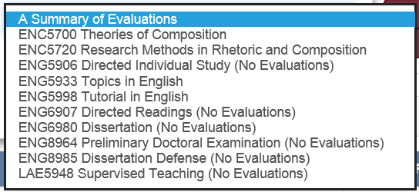

By default, the generated report will not include SPCI course evaluation summary data for semesters disrupted by COVID-19. An option is provided in the report selection dialog to override this behavior to include SPCI student evaluations for all semesters.

Distinguished Teaching Award Cover Sheet

This report is exactly like the Teaching Award Course Cover Sheet report, except in this case, the reporting period is 6 years. SPCI course evaluation data was first introduced at FSU in Spring 2013. Reporting for semesters prior to 2013 will include SPOT/SUSSAI student evaluation data.

(7) Other Reports

Graduate Committees as Reported by GST

This report function pulls information directly from the Graduate Student Tracking (GST) system. This system is used by the Graduate School as the official record regarding graduate committees. GST provides functions for the Graduate School to check the composition of graduate committees to insure they follow university policies and links with manuscript clearance for the approval of theses and dissertations.
This report provides an option to report currently active committees or all graduate committees. Information is presented in a spreadsheet with columns for student name, academic plan, current program status, faculty committee role, student admit term, and graduation term.

The Office of Faculty Development and Advancement (FDA) has ordered special handling of SPCI student evaluation reports. By default, semesters that were disrupted by COVID-19 are excluded from SPCI student evaluation reports. At the time of this writing, those semesters include Spring and Summer 2020.
Course types include Class Lecture, Laboratory, Directed Individual Study, Graduate Dissertation, Supervised Teaching, Discussion, Graduate Thesis, etc.
Course enrollment information in Student Central prior to Fall 2013 makes it impossible to accurately compute grade distributions for some course sections (this is when the FSU student system was migrated from a home-grown system to the PeopleSoft system). Prior to Fall 2013, legacy grade data is used for this reporting.
Course enrollment information in Student Central prior to Fall 2013 makes it impossible to accurately compute grade distributions for some course sections (this is when the FSU student system was migrated from a home-grown system to the PeopleSoft system). Prior to Fall 2013, legacy grade data is used for this reporting.
Depending on the type of form, this would apply to a list of artists, performers, presenters, exhibitors, and other such lists as may be appropriate in the context.
The research summary does not consider citations from the category of “Reviews of My Research and Original Creative Work by Other Authors”.

