FEAS+ Reference Manual

Dave Yancey
Florida State University
Revised: April 24, 2020
Table of Contents
Section 1: Overview 2
1.1 Document Overview 2
1.2 System Overview 2
1.3 User Roles 3
1.4 The Home page 4
Section 2: Add/Edit Entries 6
2.1 Selecting New Entries 6
2.2 Creating a New Entry 9
2.3 Selecting from the Entry List 14
2.4 Editing an Existing Entry 16
Section 3: Import 19
3.1 Importing FSU Sources 19
3.2 Importing Publication Files 21
3.3 Importing ORCID Works 23
Section 4: Publish 26
Section 4: CV 27
4.1 Promotion and Tenure CV 27
4.2 QER CV 28
4.3 Custom CV 29
4.4 Other Vita Documents 31
Section 5: Report 33
5.1 Student Evaluation Reports 33
5.2 Teaching Summary Reports 34
5.3 Grade Distribution Summary Reports 39
5.4 Research Summary Reports 40
5.5 Summary of Accomplishment Reports 44
5.6 Teaching Award Reports 47
5.7 Other Reports 49
Section 6: Export 50
Section 7: Standard Menu Functions 52
7.1 Faculty Search 52
7.2 Expertise Search 54
7.3 Preferences 55
7.4 User Manuals 59
Section 8: Advanced Menu Functions 60
8.1 Faculty Search (Advanced Features) 60
8.2 Keyword Search 61
8.3 CV Item Reporting 63
8.4 Department Reports 64
8.5 Delegate 68
Section 9: Supplemental Documentation References 70

Section 1: Overview

1.1 Document Overview

This document describes FEAS+ (Faculty Expertise and Advancement System) which was released August 2019. This new version replaces the old FEAS system; it provides similar functionality, but packaged in a new way with major changes to the user interface. This new design was based on mockups spearheaded by the ITS User Experience group; several faculty focus groups reviewed the mockups as well as early beta versions of FEAS+. This new version is intended to address some of the issues raised with the old FEAS system. Information entered into the old FEAS system was copied over into the new system.

FEAS+ is a web application that supports the management of faculty information with content sufficient to generate an FSU promotion and tenure (P&T) curriculum vitae, specialized faculty promotion curriculum vitae, quality enhancement review (QER), and other vita formats and reports. Information entered into this system is stored in a database and includes general information, teaching activities, scholarly or creative activities, and service. This information can be used to generate analysis reports, as well as the automated construction of research and teaching reports, SPCI student evaluation reports, grade distribution reports, annual summary reports, formatted general and custom vitae, and other faculty summary reports.

The application is available at the following web address:

https://feas.fsu.edu

1.2 System Overview

This system provides an interface for faculty to enter or update information related to publications, presentations, exhibitions, teaching, service, honors, expertise, professional experience, and more. Delegate authority may be granted to individuals to enter information on behalf of faculty.

Options are provided to download information from other FSU databases, including: courses taught from Student Central, graduate committees from Graduate Student Tracking, and contracts and grants from OMNI Financials. Library publication databases may be used to search and download publication citations from such sources as PubMed, Engineering Village, Web of Science, JSTOR, and many others. A FEAS+ function is available to import publications from various citation export files such as EndNote, RefWorks, BibTeX, CSV, and XML. Functions are also available to import works from ORCID.

Functions are provided to generate vitae that are formatted as appropriate for promotion and tenure. CVs may also be generated as appropriate for specialized faculty promotion and quality enhancement reviews (QER). Other formats include the general vita, short vita, and a custom formatted vita. Faculty may also use this system to generate SPCI student evaluation summary reports, teaching summary reports, research summary reports, annual summary of accomplishment reports, teaching award documents, grade distribution reports, and graduate committee reports.

Reports and CVs are commonly based on information in the FEAS+ database. Some reports integrate information from other university data systems. Faculty can generate CVs and reports based on their own information, but access to others is limited to those with special authorization. Faculty do have the ability to pubish their CV which is accessible to all of their colleagues and the world at large.

Functions are provided for deans, chairs, and administrators to search for faculty information in the FEAS+ database, generate reports of publications and other research, and generate a formatted CV for faculty in their area. This is "View access" as described below.

1.3 User Roles

When a user first accesses this web site, a login screen is presented. The user should enter his/her FSUID and password, which is the same login userid used for my.fsu.edu, OMNI, and other university web applications. The login identifies the user to the application. Non-employees that have no special roles in the system will be denied access.

In summary, the special roles that can be granted to FEAS+ users include:
- Administrator. System administrators have access to setup, configuration, and input form definition functions. User access administrators are able to grant special roles to other users. Help administrators are able to alter form and field help messages. Administrative functions are not discussed in this document.
- Delegate. Delegates have the ability to enter information and generate CVs on behalf of other faculty. Delegate status can be granted to enter information for one or more individuals, one or more departments, one or more colleges, or for the university.
- View. Users with view access can generate CVs and perform analysis/reporting for some collection of faculty. View access can be granted for one or more departments, one or more colleges, or for the university.

1.4 The Home page

After logging in, users are presented FEAS+ home page, such as the following.

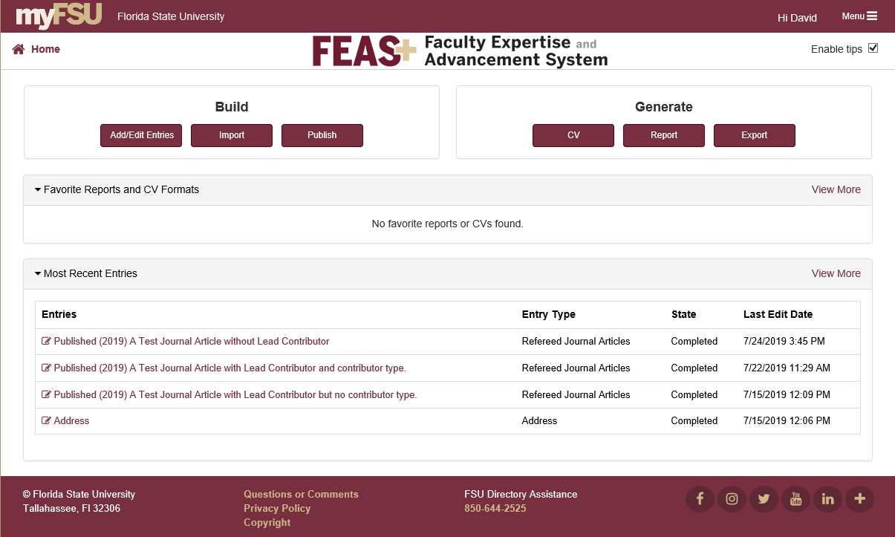

The header and footer displayed above are included on all pages of the application. Key functional elements are illustrated below.

Application Home. Click this link to always return to the application home page.

Application Menu. Click this link to present a dropdown menu of functions.

Enable Tips. Check or uncheck this to enable/disable popup help on various buttons and links.

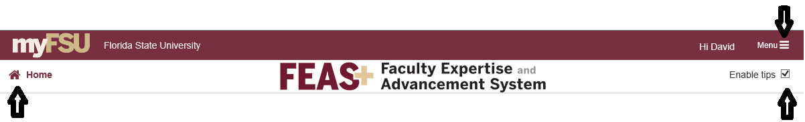

When the menu icon is clicked, a drop down menu of functions is presented. Following is a typical drop down menu.

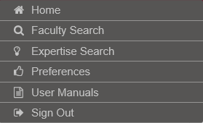

However, additional functions may be provided if the user has either the View or Delegate role. An expanded set of menu options is illustrated below. These functions are described in later sections.

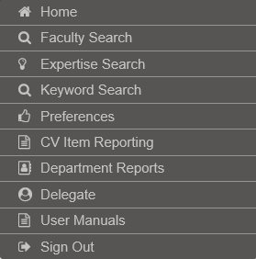

Section 2: Add/Edit Entries

From the application home page, the "Add/Edit Entries" button may be clicked to display the editor used in order to enter or update citations in your CV.

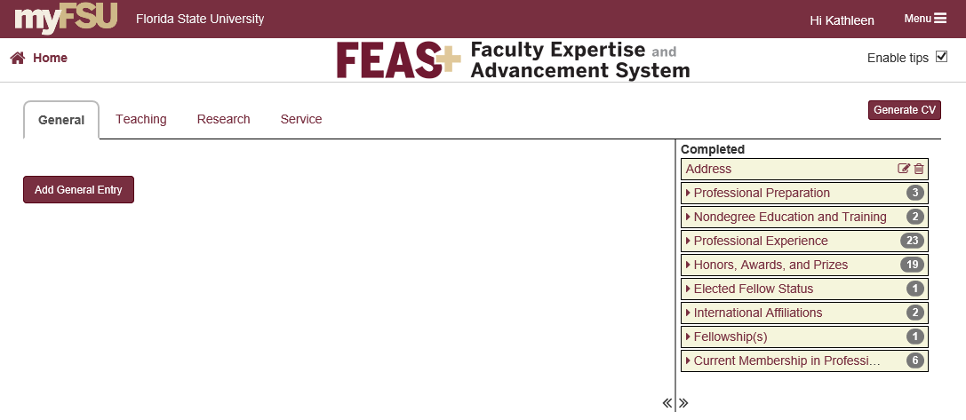
The CV entries are segregated into four tabs: General, Teaching, Research, and Service. The entries that have already been entered are found on the right hand side. The left hand side displays entry forms and new citation type selection.

These two areas are separated by a drag bar. Click and hold down the mouse in order to drag the vertical separator left or right to provide more presentation space.

2.1 Selecting New Entries

Click the Add Entry button to select a new citation type. A series of dropdown menus will lead the user to select a type of entry. In the illustration below, the user selected a new Research entry, first Publications was selected, followed by Journal Articles. Once all the selections have been made an entry form is displayed.

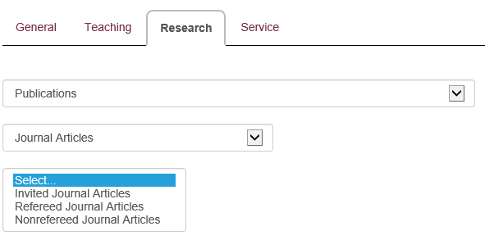
The user can make an alternate selection from any of the dropdown items. For example, the user could change the selection from Publications to Presentations and the menu would display appropriate subcategories. The categories of entries is summarized below.

General
Address
Professional Preparation
Nondegree Education and Training
Professional Credentials
Expertise
Visiting Professorships
Artist/Designer in Residence
Honors
Current Membership in Professional Organizations

Teaching
Teaching Category Preface
Courses Taught
Clinical Practice
Supervision of Clinical Practice
New Course Development
Curriculum Development
Management of Multiple Course Sections
Doctoral Dissertation Supervisory Committee
Master's Thesis Supervisory Committee
Bachelor's Thesis Supervisory Committee
Supervision of Student Research Not Related to Thesis or Dissertation
Additional Teaching Not Reported Elsewhere

Research
Research and Original Creative Work Category Preface
Program of Research and/or Focus of Original Creative Work
Publications
Journal Articles
Books
Monographs
Book Chapters
Monograph Chapters
Encyclopedia Entries
Proceedings
Reviews
Tests, Instruments, or Assessment Measures
Summaries
Reports
Newsletter Articles
Presentations
Papers at Conferences and Symposia
Invited Keynote and Plenary Presentations
Presentations at Conferences and Symposia
Workshops
Invited Lectures and Readings of Original Work
Master Classes
Clinics
Original Creative Works
Novels and Novellas
Short Stories
Poems
Images
Scripts or Screenplays
Films
Musical Compositions
Musical Arrangements
Studio Recordings
Original Choreography
Performances
Exhibitions
Edited Original Works
Digital Projects
Information and Communication Technology
Inventions
Contracts and Grants
Postdoctoral Supervision
Reviews of My Research and Original Creative Works by Other Authors
Additional Research or Original Creative Work Not Reported Elsewhere

Service
Service Category Preface
Florida State University
The Profession
Editor for Journals
Guest Editing for Journals
Series Editor for Books
Editorial Boar Memberships
Guest Reviewer for Refereed Journals
Reviewer for Textbooks
Juror for a Performance
Judge for an Exhibition
Exhibitions Curated
Chair of a Symposium
Reviewer or Panelist for Grant Applications
Service to Professional Associations
Interviews
Other Universities
The Community
Consultation
Additional Service Not Reported Elsewhere

2.2 Creating a New Entry

The following illustrates a typical new entry form display. The fields displayed on the form will vary by entry type. An asterisk (*) appears to the immediate right of each field that is required. In the example below, only the Begin Date and Artist in Residence fields are required.

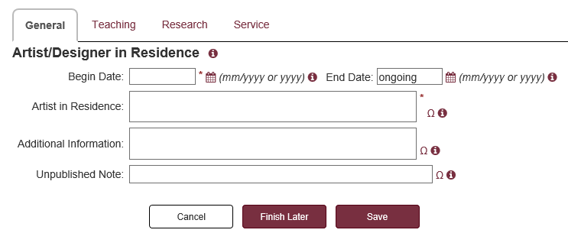
Most forms have an "Additional Information" field and an "Unpublished Note" field. These two optional fields provide additional information about the entry. The Unpublished Note does not appear in any generated document. The Additional Information field is displayed on the P&T and Specialized Faculty Promotion CV, but not on the General, Short, or QER CV. The P&T curriculum vitae and the specialized faculty promotion curriculum vitae require that each citation of published work since employment at FSU, or since last promotion at FSU, include a one-sentence description of the work, as well as a statement that identifies the status of any co-authors and their institutions.

Each date field in the data entry form expects the value to be formatted as a year (e.g., 2019) or as a month/year (e.g., 10/2018). An improperly formatted value cannot be saved. At the end of each date field, a calendar icon is presented and, when clicked, will trigger the appearance of a popup display that can assist in the selection of a date.

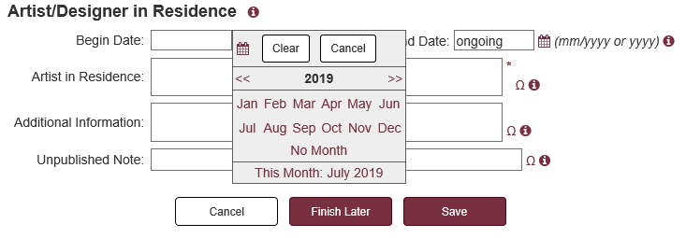

Click the << symbol to select a year from the previous decade, or >> to select a year from the next decade. If “No Month” is selected, the date entry is limited to the year.

Some text fields are followed by the suggested list symbol , which if clicked will present a popup list of suggestions that may be selected for the field. Alternatively, text may be directly typed into the field.

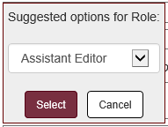

At the end of each of the text fields, there is a special Ω symbol, which is provided for entering special symbols and characters into the field. When this symbol is clicked, a dialog box containing various symbols is presented, as illustrated below.

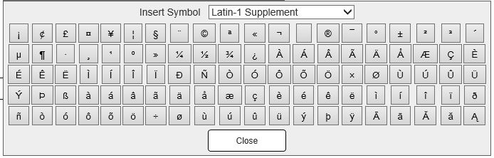

Choose from the drop-down list to select alternate symbol sets such as Cyrillic, Greek, Mathematical Operators, Dingbats, Extended Latin, etc. When one of the symbols is clicked, it is appended or inserted into the associated text box on the form. With these extended characters and symbols, one can construct foreign references such as “University of Jyväskylä” or other references such as “β particles.”

The caret (^) is a special character which may be used to enclose scientific names that should be italicized, or reverted to roman within an italicized field. For example consider a refereed journal article title such as:
Natural genetic variation in the courtship repertoire of male ^Drosophila melanogaster^
Such a title would be rendered in the vita document as:
Natural genetic variation in the courtship repertoire of male Drosophila melanogaster

Special expressions are provided which may be typed into text fields to represent symbols and accented characters. For example, \Sigma may be entered which will be replaced by the Unicode character Σ. Foreign accents may be entered using an expression like \~a which will be replaced by the Unicode character ã.

In addition, subscripted and superscripted text may be represented via expressions such as +{superscripted text} and -{subscripted text}. For example, the text {\=a}+{2} would be rendered as ā². A more complete discussion with examples of these special text expressions is provided in “Text Expression Reference” which is available from the user documentation link on the main menu.

In the preface forms and in the “additional information” fields, users may introduce a carriage return in the display by inserting a pilcrow (¶) character. This character may be inserted from the symbol picker or by using the text expression \P.

On the doctoral, master’s and bachelor’s thesis supervisory committee forms (under teaching) and on the journal article forms (under publications), there are special lookup functions tied to the FSU’s DigiNole repository. The "DigiNole Lookup" function as illustrated below on a doctoral committee chair form will use the student name, graduation year, and degree level to lookup the thesis title and PURL from the DigiNole thesis repository. If a match is found, a popup dialog will ask the user to confirm the match. If accepted, the thesis and URL fields are populated.

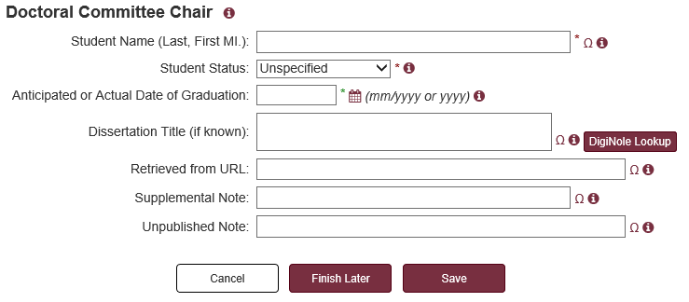

Similarly, a [DigiNole Lookup] function is provided on published journal article forms. This function will use the DOI if provided; otherwise, it will use the article title and publication date to locate the citation in FSU’s repository. If the citation is found in the article repository, the PURL is returned and is placed in the “Retrieved from URL” form field. When provided in a citation, the URL field is rendered as a hyperlink in generated CV documents.

Forms that include lists of contributors (journal articles, exhibitions, presentations, etc.) may include a scrolling list of textboxes as illustrated below.

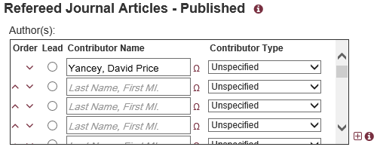

The functions in this display may be used to move contributors up and down in the list. The function can be used to expand the vertical size of the scrolling contributor list. This may be convenient if there are a large number of contributors.

In order to provide some guidance regarding the nature of the information to be entered in each form, various forms of help are provided. Users may mouse over the symbol that appears to the immediate right of fields for information related directly to that field. A typical field help popup is illustrated below.

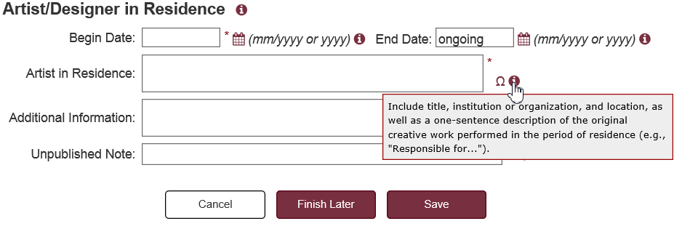

On the data entry form title line, clicking the information icon will expand or contract information about the form. The following illustrates an expanded description of the Doctoral Committee Chair form.

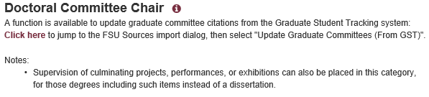

In addition, if Tips are enabled, a popup will appear when the user rolls over certain buttons or areas as illustrated below. Turning off tips will not affect the above form and field information icons.

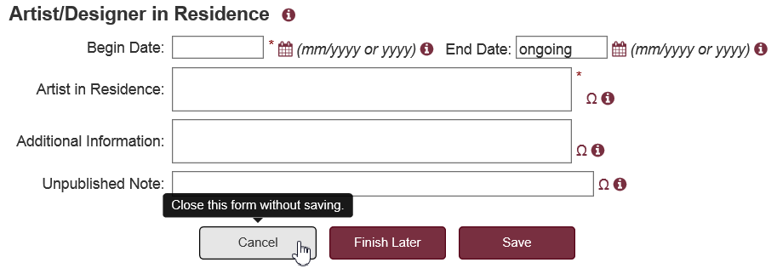

On entry forms, the button functions provided at the bottom will vary depending on whether the user is a faculty member or a delegate entering citations on behalf of a faculty member; it will depend on whether this is a new citation or updates are being performed on a previously saved citation; and if this is a previously saved entry, it will depend on how it was saved.

The following are the button functions presented to a faculty member on a new citation form.



When Cancel is clicked, the user is returned to the drop down menu for new form selection.

When Save is clicked, the form is checked to insure that all required fields have been provided and values are formatted appropriately. When a problem is detected, a popup dialog is presented to explain the nature of the problem. When a faculty member successfully saves an entry, it is considered "completed" and saved to the database.

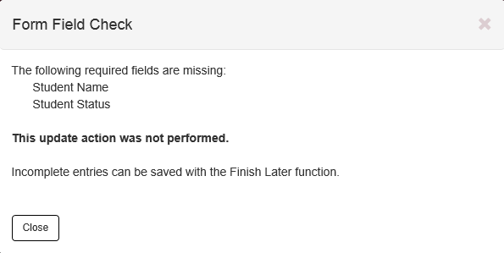

When "Finish Later" is clicked, the record is considered in-progress and is saved in a special place that can be completed later. Entries saved in this way are not checked and need not have all required fields supplied. Later the Finish Later entry may be edited, completed, or deleted, as appropriate. When saved, it will be subject to constraint checks.

2.3 Selecting from the Entry List

After some information has been entered into the database for the vita, a summary of entries will display in the right hand column. In the illustration below, a fellowship entry was selected and its associated form is displayed. The currently displayed entry is highlighted in blue.

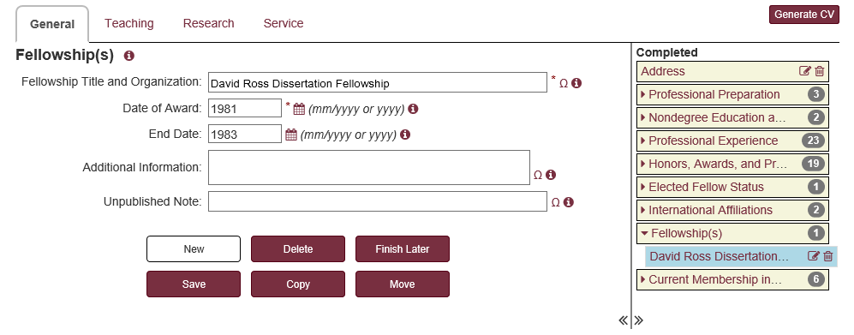
The display of entries in the right side column fall into four groups:

Completed these entries have been entered or accepted by a faculty member and have passed all checks performed on form entries. These entries will appear in generated CVs and reports.

Needs Review these entries have been entered or updated by a delegate on behalf of a faculty member. These entries are not part of the CV and must be accepted, rolled back, or deleted.

Imported these entries have been created and saved due to some import action. These entries are not part of the CV and must be accepted or deleted.

Finish Later these entries were saved by the faculty member in an incomplete state. These entries are not part of the CV and must be updated, accepted or deleted.

Following is an illustration of an entry list with multiple groups of entries.

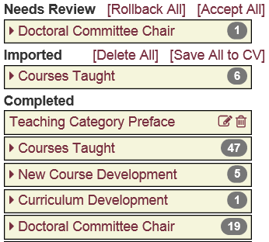

Items, such as the following are form categories. The number on the right side indicates the number of entries that are in this category.

Note that some categories in the list may have at most one entry (e.g. Address, Teaching Category Preface, etc.) in which case the entry is displayed rather than the category

Click the category title to expand the list to show the entries in the category. These entries are in descending order by event date. Click the entry to view or edit the form for this entry.

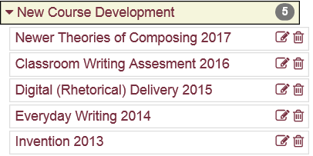

The functions displayed on the right side of the entry will vary depending on the type of entry, and how it came to be in the list. Common functions include the following.

Edit. Display the form for this entry which may be updated.
View. Display a downloaded course section record detail. No editing is available.
Delete. Remove the entry.
Accept. Accept an entry as completed from the imported, needs review, or finish later groups.
Rollback. Rollback all changes made by a delegate to an entry originally made by the faculty member.

The above functions deal with a single entry. Functions are also provided to deal with whole groups of entries in the Finish Later, Imported, and Needs Review groups.

[Accept All] Accept all entries in the Needs Review category. Perform a check for required fields; a popup dialog will display all entries saved to Completed. All entries that failed the check are left in place.

[Rollback All] Rollback all changes made by delegates to citations found in the Needs Review group. Any new citations created by a delegate will be removed.

[Delete All] Remove all citations in the Imported or Finish Later group.

[Save All to CV] Perform a check for required fields for all entries in the Finish Later or Imported group. Entries that pass are moved to Completed; entries that fail are left in place.

2.3.1 Selecting Courses Taught from the Entry List

The presentation of Courses Taught in the entry list is a little different than other entry categories. In this case the tan colored blocks represent courses that are matched up with course sections from Student Central. White blocks represent course entries that are not matched to FSU course section records. Entries directly under Courses Taught are used in preparing P&T, General, Short, and other CVs. The downloaded course sections from Student Central appear in the QER CV, Teaching Summary Reports, and Annual Summary of Accomplishments.

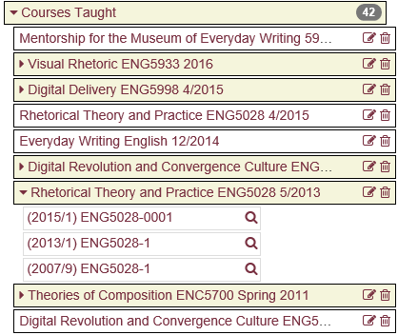

Course summary entries and downloaded course section records are matched up on the basis of course number. If a downloaded course section record is found with a course number that is not matched by a summary course record, a new summary course record is created and placed in the imported group.

2.4 Editing an Existing Entry

The figure below illustrates a previously saved entry selected for edit. The selected citation in the list is highlighted in blue. The same form is presented as would be the case for new entries, but in this case previously saved values are displayed.

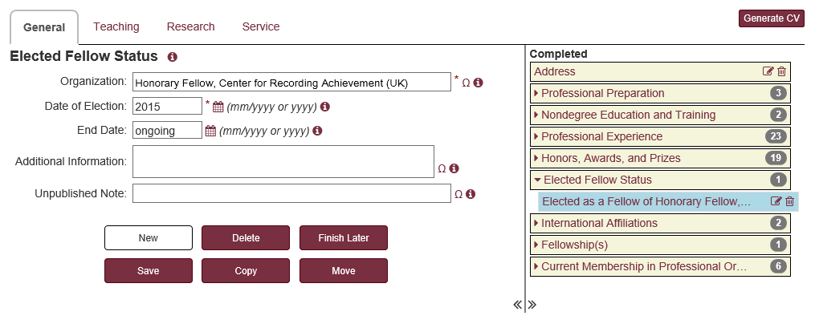

Button functions presented at the bottom of the page will vary depending on the type of entry, how it came to be in the list, and whether the user is a faculty member or a delegate. Because of differences in button behavior the button functions are described for faculty and delegates working on behalf of faculty.

Faculty button functions:

New Present a new entry form for this same entry type. Do not save any entry changes.

Delete After a confirmation dialog, permanently delete this entry.

Finish Later Save the incomplete entry without checking for required fields in the Finish Later group.

Save Check for required fields and save as a completed entry.

Copy Create a copy of the entry.

Move Present a dialog for changing the form type for the entry (e.g., from refereed journal article to invited journal article). Depending on the selection, it may cause fields to be added or removed from the form. If this causes the resultant entry to be missing required fields, the entry is moved to Finish Later.

Status Present a dialog for change the status for an entry (e.g., from Submitted to Published). Depending on the selection, it may cause fields to be added or removed from the form. If this causes the resultant entry to be missing required fields, the entry is moved to Finish Later.

Update Save a change to an entry in Finish Later, Needs Review, or Imported. The form is not checked for required fields and is not moved to Completed.

Save to Vita This is available for entries in Finish Later and Imported. Check for required fields, save any changes, and move to Completed.

Accept Approve changes made by a delegate for this entry in Needs Review. If the entry was flagged for delete, permanently delete the entry. Otherwise, check for required fields and move to Completed.

Rollback Undo changes made by a delegate for this entry in Needs Review. If the entry was created by the delegate, permanently delete the entry. Otherwise, restore this entry to its former state prior to changes made by the delegate.

Delegate button functions:

New Present a new entry form for this same entry type. Do not save any entry changes.

Delete Present a confirmation dialog for the delete action. If the entry was created by the delegate, then permanently delete the entry. Otherwise, flag the entry as deleted and move to Needs Review.

Save Save any changes to the entry and move to Needs Review.

Copy Create a new entry in Needs Review based on a copy of this entry.

Move Present a dialog for changing the form type for the entry (e.g., from refereed journal article to invited journal article). The changed entry is moved to Needs Review.

Status Present a dialog for changing the status of the entry (e.g., from Submitted to Published). The changed entry is moved to Needs Review.

Rollback Undo changes made by a delegate for this entry in Needs Review. If the entry was created by the delegate, permanently delete the entry. Otherwise, restore this entry to its former state prior to changes made by the delegate.

Section 3: Import

When the Import button is clicked from the application home page, a dialog is presented in which the user selects the type of import.

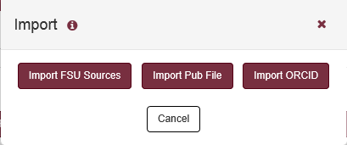

3.1 Importing FSU Sources

Choosing "Import FSU Sources" presents options to update the FEAS CV with downloaded information for courses taught from Student Central, graduate committees from Graduate Student Tracking, or pending or funded grants from OMNI Financials. That dialog is illustrated below.

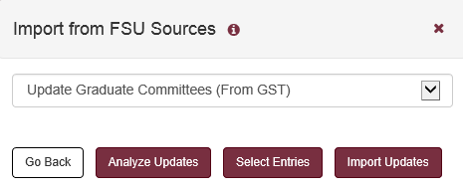

The "Analyze Updates" button will generate a report of proposed additions, deletions, and changes to citations in the faculty CV. No changes are actually made.

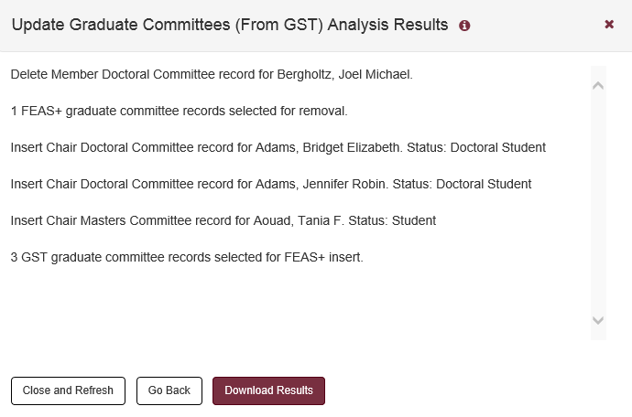

The "Select Entries" button will present a list of proposed changes which associated checkboxes. Only those selected changes are applied when "Import Selections" is clicked.

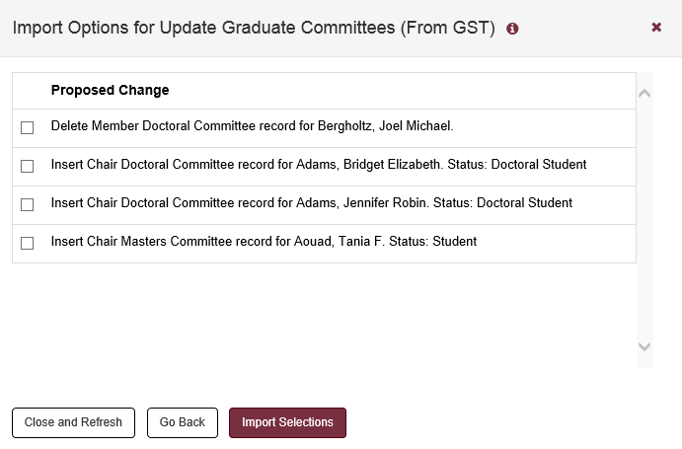

The "Import Updates" button will perform the exact same analysis, but it will also import all the changes into the FEAS database.

If the import function is performed by a delegate on behalf of a faculty member, then all changes will be maintained in the "Needs Review" grouping of citations as illustrated below.

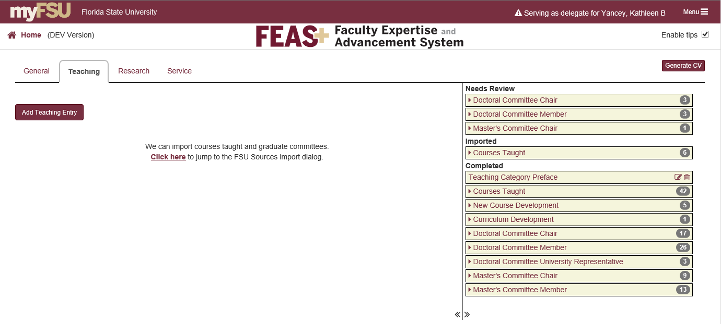
Citations under "Needs Review" are not included in the faculty member's CV. In order to complete this import, the faculty member must log into FEAS and accept the citations. These can be done by selecting the citations one-by-one or clicking "Accept All".

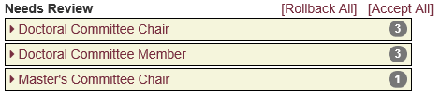

A very similar process if followed if the faculty member imports information for themselves. In that case the citation changes caused by the import action will be found under the "Imported" grouping. As before, these citation changes must be accepted before they will be included in generated CVs or reports.

3.2 Importing Publication Files

Publication libraries such as PubMed, JSTOR, Web of Science, and others provide mechanisms to search the library, select citations, and export them into an exchange file. This FEAS+ function imports publication exchange files formatted as EndNote, RefWorks, BibTeX, XML, and CSV.

From the Import dialog, click the "Import Pub File" button. The resulting dialog is illustrated below. Click the icon to provide additional information about the dialog and expose a drop down menu of additional reference documentation.

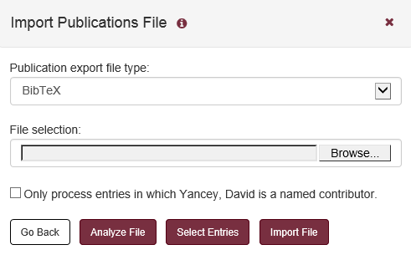

Once an export file type has been selected and the file has been selected for import, several processing options are available. The "Analyze File" button will generate a report regarding the citations. If any citations are found to already exist in the faculty member's citations, then those citations are flagged and excluded from import. The report will indicate which citations should be imported. Click "Select Entries" to selectively import the entries. Click the "Import File" button to initiate the import of all the non-duplicate citations into FEAS. The result is illustrated below.

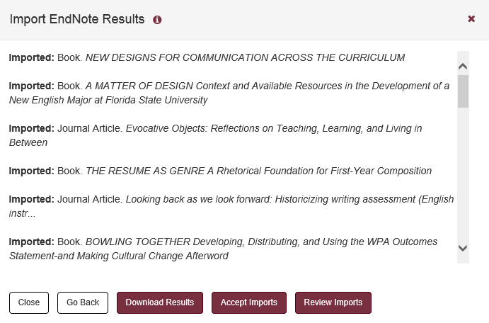

The report will indicate those citations that were successfully imported and those that were excluded based on duplication or for any other reason. Citations that are imported by the faculty member will be placed in the "Imported" area. As such, these citations will not be included in the faculty member's generated CVs or reports. Click the "Review Imports" button to view the imported citations.

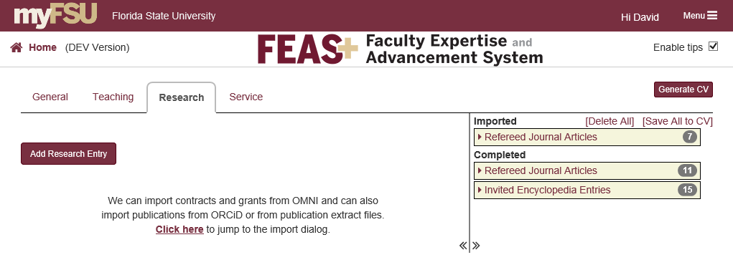

The citations may be individually edited, deleted, or accepted. By accepting an imported citation, the citations is checked to ensure that all required fields are provided. If the entry has all required information, then the citation is moved into the completed section. Those downloaded entries that fail the requirement check will remain in the "Imported" section until they are edited or deleted.

Citations may be checked en-masse by clicking the "Save All to CV" link. This will present a dialog with the import results and if any citations did fail the check, it will indicate the nature of the problem.

About Delegates

If the FEAS import is performed by a delegate on behalf of a faculty member, the citations are imported into the "Needs Review" section, rather than the "Imported" section. The delegate may edit these citations but may not accept them on behalf of the faculty member

3.3 Importing ORCID Works

ORCID (http://orcid.org) is an international not-for-profit organization created by the research community. They provide a persistent digital identifier (an ORCID iD) that distinguishes you from other researchers and a record that supports automatic links among all your professional activities. ORCID provides a registry of works (publications, conference presentations, etc.) that have been linked to your Orcid iD either by you or by a trusted organization. Each of these work records has a visibility setting: everyone, trusted parties, or only me. Thus, the researcher can regulate access to his/her ORCID records.

FEAS+ provides a means of connecting your ORCID iD and provides a function to import your works as entries into FEAS+. Access to ORCID works is constrained by the visibility assigned to each record.

Your ORCID iD may be connected to FEAS in one of three ways:

- Public. Your ORCID iD may have been entered by an administrator into the FEAS+ database from other university data sources. This is treated as an un-authenticated identity and can be used to download public (everyone) works.
- Authenticated. Based on prompts, the researcher has authenticated their ORCID iD by logging into the ORCID system, but did not (or has not yet) approved FSU as a trusted organization. This can be used to download public (everyone) works.
- Trusted. Based on prompts, the researcher has authenticated and chosen to approve FSU as a trusted organization. This can be used to download works with a visibility setting of public (everyone) and trusted.

Options are available in FEAS+ to establish an ORCID iD connection and to upgrade the connection from Public to Authenticated, and from Authenticated to Trusted. Functions available to establish this connection are available in FEAS+ either in “Preferences” or in “Import”.

When the ORCID function is selected, the user is presented information about the status of the ORCID iD connection to FEAS+ and functions are provided to establish and/or upgrade the connection. (This is similar to the functions provided under Preferences.) If the ORCID iD connection has been previously established, then no further action is required for the management of that connection. If a connection exists, then buttons are provided to download available ORCID works to FEAS. In the screen shot illustrated below, the user has established an authenticated relationship with ORCID and thus works with public visibility may be downloaded.

v 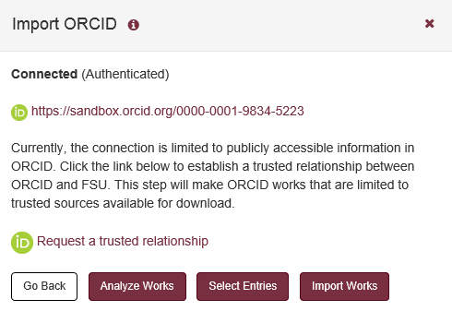

Note that FEAS+ delegates may not establish or upgrade the ORCID connection, but may use the connection to download information on behalf of the faculty member.

The "Analyze Works" button downloads and generates a report of information available in ORCID and what could potentially be loaded. The "Select Entries" button presents a list of potential entries with checkboxes that may be selected in order to selectively import entries. The "Import Works" also downloads citations and generates a report, but also loads all available citations into the FEAS+ database. In all cases, a duplicate check is performed… if the citation appears to be a duplicate of a citation already in FEAS+ in any category (Completed, Imported, Needs Review, Finish Later), it will not be accepted for import.

Citations that are imported by the faculty member are placed in the imported category of citations. These imported citations must be accepted before they will be included in reports or vitae. Similarly, citations that are imported by delegates are placed in the needs review category and must be accepted before they will be included in reports or vitae.

After an import is performed, buttons are available to "Accept imports" and "Review Imports". If the Accept button is clicked all of the citations are constraint checked and if they pass, they will be moved from the Imported to Completed section.

ORCID supports a variety of works, but the FEAS+ import function only supports a limited set of works as listed below

ORCID Work Category/Work Type Imported as FEAS Citation Type
- Publication
  - Book Chapter Refereed Book Chapter
  - Book Refereed Book
  - Edited Book Edited Book
  - Journal Article Refereed Journal Article
  - Manual Nonrefereed Report
  - Report Nonrefereed Report
- Conference
  - Conference Paper Refereed Proceedings
- Intellectual Property
  - Patent Patent

If a given ORCID works entry contains a BibTeX citation, it will be parsed and used in lieu of any field values obtained in the ORCID download. Supported BibTeX citation types include: article, book, inbook, inproceedings, techreport, conference, incollection, conference, proceedings, manual, and patent.

Section 4: Publish

As discussed earlier in this manual, faculty can generate CVs and reports based on their own information, but access to others is limited to those with "View" authorization. The publish function makes a faculty CV accessible to all of their colleagues and the world at large. Essentially, the publish function creates a formatted CV document based on entries available at the time; the generated document replaces any previously created published CV and makes it available on a public website.

When the Publish button is clicked from the application home page, a dialog is presented which provides information on the faculty member's previously published CV, current preference for published CV format, and whether a newly published CV would be marked as Draft. The following dialog illustrates a case where no CV has been previously published.

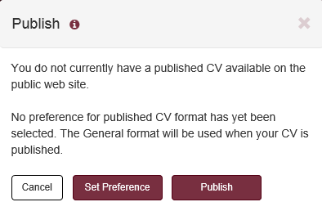

The preferred format to be used for generating the published CV document may be selected from preferences in the main FEAS+ menu or on this dialog by selecting "Set Preferences". When the "Publish" button is clicked, the CV is generated in the specified format and the user is provided the URL on the public website to access the generated document. The web address for published CVs on the publish website is of the following form.
http://www.fsu.edu/cvdb/FSUID.rtf

In the above address, FSUID is the FSU userid of the faculty member in upper case. "cvdb" and "rtf" must be in lower case.

You can also select published CVs from the FEAS+ faculty search menu function.

Section 4: CV

When the CV button is clicked from the FEAS+ home page, a dialog is presented for the selection of a CV format.

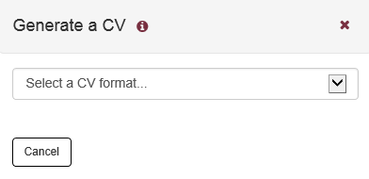

Once a CV format is selected, a submenu may appear and a description of the CV format is provided as illustrated below. The submenu will vary, depending on the selected CV format.

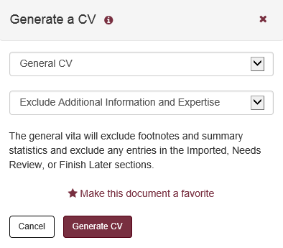

A link is provided to make the selected CV format a favorite. Once selected, this CV type will appear in a list of favorites on the FEAS+ home page which may be directly selected.

4.1 Promotion and Tenure CV

When this option is selected, FEAS+ pulls all “completed” citations associated with the user and builds a rich text file (RTF), which is formatted as appropriate for a promotion and tenure CV. The format of this document is designed to match the template approved by the university P&T committee. (This will exclude items in the Needs Review, Imported, and Finish Later sections.) Depending on the web browser used, the user will be prompted to open (display) or save the generated document. Tips on managing the display of generated documents are provided in FEAS+ FAQs, available from the FEAS+ documentation menu. The following is displayed by Internet Explorer on Windows 7.

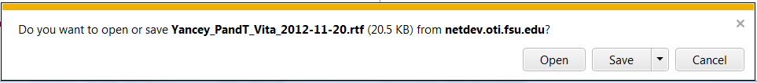

By default, the name of the file is of the form: LastName_VitaType_DocDate.rtf, where the DocDate is the date that the CV was last revised. If the CV has any citations in the needs review, imported, or finish later categories, then the document will begin with the title “DRAFT Curriculum Vitae”. Once only completed citations remain, the DRAFT will be dropped.

The FSU starting and promotion dates are used to flag teaching, research, and service items as required by the promotion and tenure vita template. Items before your last promotion at FSU and items while working at another institution are indicated with a footnote. These items are based on the information provided in the Professional Experience category. The FSU Start date is based on the earliest From Date in which the institution is Florida State University. The Last FSU Promotion date is based on the latest From Date in which the institution is Florida State University and the promotion flag is checked.

The P&T CV requires that each citation of published work since employment at FSU, or since last promotion at FSU, include a one-sentence description of the work, as well as a statement that identifies the status of any co-authors and their institutions. When the P&T CV is generated, a check is performed for information in the Additional Information field of these publication citations, and inserts a warning message in the CV if the required information is not provided.

4.2 QER CV

The Quality Enhancement Review (QER) vita is a special short form faculty vita for state mandated program reviews. The QER formatted CV requires course section information at a greater granularity of detail than that provided in the “Courses Taught” category of the P&T CV. By default, the list of courses used for the QER vita is limited to those offered in the last five years and has an instructional mode of class lecture, laboratory, discussion, individual performance instruction, or internship. In addition, doctoral and master's supervisory committee information is pulled directly from the Graduate Student Tracking (GST) system, rather than from citations in the FEAS database.

4.3 Custom CV

This function is provided to generate vitae in a variety of user-specified formats. The custom-vita function provides an interface to construct templates that select and format the display of database information in the form of a vita.

When “Custom CV” option is selected from the CV selection dialog, a list of currently available templates is presented as illustrated below. Once one of the radio buttons is clicked, the "Generate CV" button will be displayed; clicking that button, a CV document will be generated using the format specified in the template.

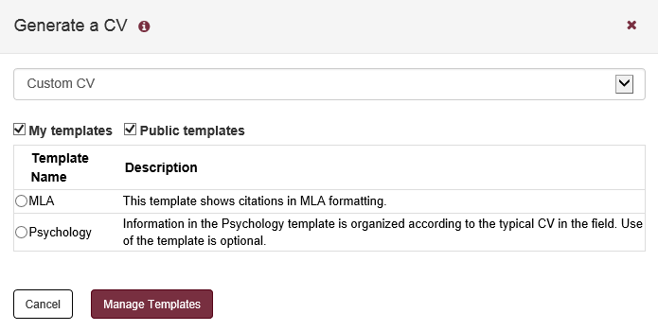

Click the "Manage Templates" button to edit existing or create new templates. The following page is displayed when this button is clicked.

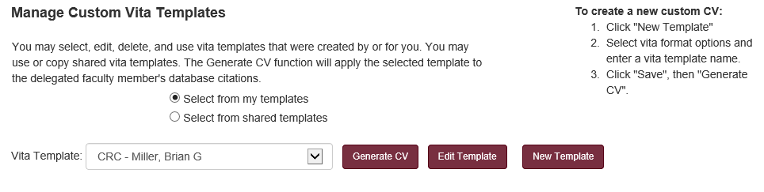

If the user is operating as a delegate and is entering data and generating reports on behalf of a faculty member, then the initial display is expanded to allow for the selection of the delegate’s templates in addition to shared templates and the faculty member’s templates.

The templates that are displayed in the drop down list are those that have already been created and saved. At this point the user could select a template and click the “Generate CV” button to generate an associated document. Click the “Edit Template” or “New Template” buttons in order to bring up the template editor as illustrated below.

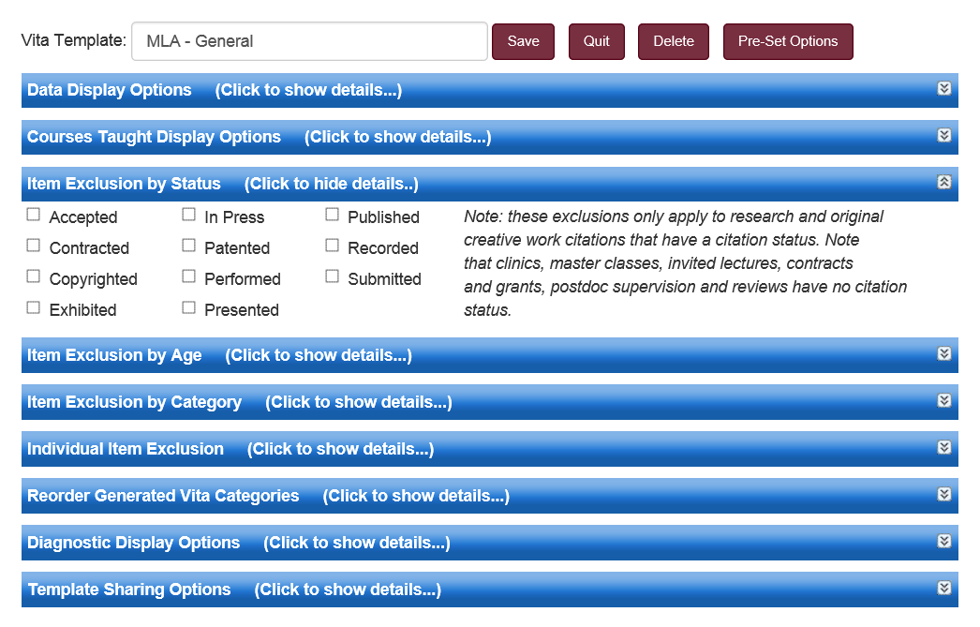

The “Pre-Set Options” button is displayed when editing a custom vita template. When clicked, the following dialog is displayed.

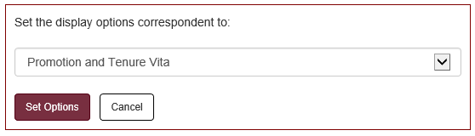

Several types of vita formats are provided in the drop down list which correspond to vita display options presented in various FEAS menus. If one of these options is selected and the “Set Options” button is clicked, it will set the appropriate custom format options which would be suitable to generate a vita in the selected format. The idea here is that one could start with this vita format and then make a few additional changes to the format options and then save the template.

When editing a template, there are a series of blue bars which can be clicked to hide or display template definition details. The P&T vita format could be generated, for example, by choosing to exclude the Expertise category under the Item Exclusion by Category bar.

In summary, the categories of the template definition include the following.

- Data Display Options
This template category provides options to include/exclude footnotes, additional information, prefaces, publication numbering, pre-publication dates, summary statistics, and “Finish Later” data. An option is also provided to format citations in an MLA style.
- Courses Taught Display Options
This template category provides options for displaying courses taught. It may either include a summary of courses entered from the Add/Edit Entries courses taught form, or course section details downloaded from Student Central.
- Item Exclusion by Status
This template category provides options to include/exclude citations that have a status such as Accepted, Contracted, Copyrighted, Exhibited, In Press, Patented, Performed, Presented, Published, Recorded, and Submitted.
- Item Exclusion by Age
This template category provides options to include/exclude citations based on the date of the citation. This could either involve a date range or simply the age of the citation.
- Item Exclusion by Category
This template category provides options to include/exclude citations based on the information category. For example, all Service could be excluded, or Invited Journal Articles.
- Individual Item Exclusion
This template category provides options to exclude specific selected citations that have been entered in the FEAS database for the user.
- Reorder Generated Vita Categories
This template category provides options to alter the ordering of the citation categories in the generated vita. For example, refereed books could be specified to come before refereed journal articles.
- Diagnostic Display Options
This template category provides options to highlight missing information, identify the person last editing the vita records, and identifying records most recently changed.
- Template Sharing Options
This template category provides an option to share your template with others and to provide a description of the template.

4.4 Other Vita Documents

There are several other options for the generation of vitae documents in the menu. These include:

- Generate a Specialized Faculty Promotion Vita.
This will generate a vita formatted like the P&T vita.
- Generate a General Vita.
A vita is generated which includes all the user’s “completed” entries. This will exclude items in the Imported, Needs Review, and Finish Later sections. The vita will also exclude P&T footnotes indicating items that occurred at another institution or before last promotion; it will exclude summary statistics that report scope for each presentation category. A option is available to include or exclude “additional information” that may have been entered for various citations.
- Generate a Short Vita.
This vita is similar to the General Vita, with the additional restrictions that each citation item must be no older than some number of years (typically 5) and that research entries with the status of “submitted,” “accepted,” “contracted,” and “in press” will be excluded. It will include only the last degree, and it will exclude the teaching, research, and service preface.
- Analysis of Missing Required Fields.
This is a special report of items in the Needs Review, Imported, and Finish Later categories. These are displayed as citations would appear in a vita with additional information about required fields that are missing a value that would be required to be “saved” in the database.

These vita forms are provided as a convenience. Generally, various vita forms can be created with the Custom Vita option as illustrated in the table below.

Custom Category | Setting | P & T | General | Short Vita
Data Display Options | Exclude P&T Footnotes |  | X | X
Data Display Options | Exclude Additional Information |  | X | X
Data Display Options | Exclude Section Prefaces |  | X | X
Data Display Options | Exclude Summary Statistics |  | X | X
Item Exclusion by Status | Submitted |  |  | X
Item Exclusion by Status | Accepted |  |  | X
Item Exclusion by Status | Contracted |  |  | X
Item Exclusion by Status | In Press |  |  | X
Exclusion by Age | Exclude by Age |  |  | X
Exclusion by Age | Display Last Degree |  |  | X
Exclusion by Category | Language Proficiency | X |  | X
Exclusion by Category | Areas of Expertise | X | X | X
Exclusion by Category | International Affiliations | X | X | X

Section 5: Report

When the Report button is clicked from the application home page, a dialog is presented in which the user may select a type of report. All of the reports are for an individual faculty member. (Departmental reports are selected from the FEAS+ Menu.)

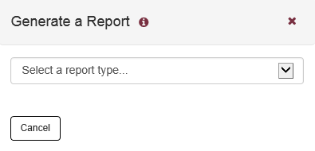

Once a CV format is selected, a submenu may appear and a description of the CV format is provided as illustrated below. The submenu will vary, depending on the selected CV format.

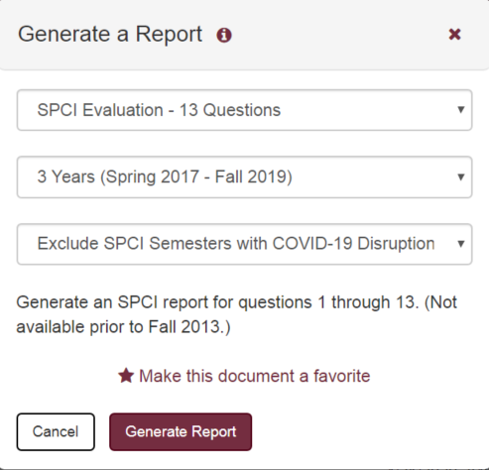

A link is provided to make the selected CV format a favorite. Once selected, this CV type will appear in a list of favorites on the FEAS+ home page which may be directly selected.

5.1 Student Evaluation Reports

SPCI student evaluation data is collected by the EvaluationKit application which is managed by the Office of Distance Learning. A public interface to this application is available at this address:
https://fsu.evaluationkit.com/Report/Public
Prior to 2013, SPOT/SUSSAI was used for student evaluations. A public interface to this data is available at this address:
https://java.odl.fsu.edu/sussai2/main.jsp

FEAS+ downloads student evaluation data to the FEAS+ database for report generation purposes.

SPCI Overall Evaluation Summary

The overall report is a summary of question 13 from SPCI student evaluations, which correspond to the overall course evaluation. SPCI evaluations were first introduced in Spring 2013. Prior to that, SPOT/SUSSAI evaluations were used. The scales used for SPOT/SUSSAI were somewhat different than those used for SPCI. In the overall report, the evaluation counts are summarized on a single page.

Each record in the report constitutes an “evaluation order”. An order is a collection of evaluations for which statistical counts are computed. Depending on the order request, multiple course sections may be combined in an order, and even multiple courses may be combined in an order. When multiple course numbers are involved in an order, they will be listed in the report. By policy, evaluations with an enrollment count under 5 are not reported.

This report type offers options for a reporting span from one to seven years. Reports prior to 2013 will include SPOT/SUSSAI data, rather than SPCI data. The particular semesters covered within the span of a year depend on the current date; the last semester reported will be the one prior to the current semester. By default, semesters disrupted by COVID-19 are excluded from the report. An option is provided in the report selection dialog to override this behavior and include all semesters within the reporting period.

SPCI Evaluation - 13 Questions

The detailed SPCI report is a summary of student course evaluation questions 1 through 13, with one page per course evaluation. Information for this report is only available since Fall 2013.

This report type offers options for a reporting span from one to seven years. Evaluation data prior to Fall 2013 will not be reported, regardless of the reporting span. The particular semesters covered within the span of a year depend on the current date; the last semester reported will be the one prior to the current semester. As with the overall SPCI report, semesters disrupted by COVID-19 are excluded from this report. An option is provided to override this behavior and include all semesters within the reporting period.

5.2 Teaching Summary Reports

Teaching Summary Report

This report is a one page summary of course sections taught. Columns for this report include semester, course number, credit hours, course name, course type, and number enrolled. There are several variants of the teaching report which include additional information. Each teaching summary report displays the "Manage Report Data" button on the report selection dialog, which is described below. Among other things, the manage report data function includes an option to update downloaded FSU course information.

This report type offers options for a reporting span from one to three years. The one year report will cover a calendar year (Spring through Fall). The particular semesters covered in the two and three year report depend on the current date; the last semester reported will be the one prior to the current semester. A more explicit selection of semesters is available in the Teaching Summary Custom Report.

Teaching Summary w/Effort

This report adds a "Percent of Effort" column to the teaching summary report, described above. This information is obtained from FACET Actual Effort information which is prepared for the Board of Governors. The availability of this information commonly lags the completion of a semester by a few months. Among other things, the "Manage Report Data" button includes options to update Percent of Effort from FACET and to manually enter or update effort information for reporting purposes.

Extended Teaching Report

This report adds student credit hours (SCH) to the teaching summary report. In addition, this report provides a summary count of course sections by course type, overall SPCI course evaluations, course grade distributions, and a summary of student research supervision.

By default, the SPCI course evaluation summary will exclude semesters disrupted by COVID-19. An option is provided in the report selection dialog to override this behavior to include all semesters within the reporting period.

Teaching Summary - Custom Report

The teaching summary custom report displays any available teaching summary report templates. Once a template is selected by clicking the associated radio button, the "Generate Report" button is displayed; click that button to generate a report using the report options specified for that template.

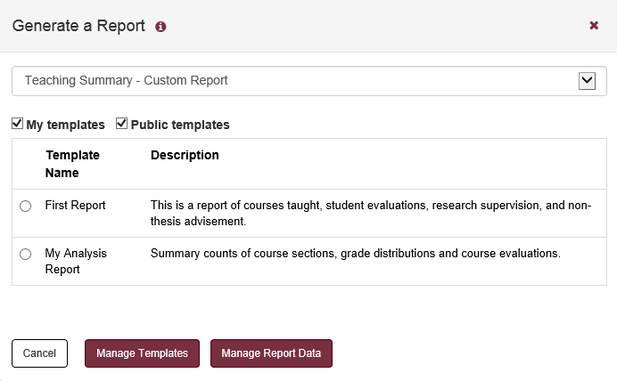

Click the "Manage Templates" button to edit or create a new teaching report templates. The following page is initially displayed.

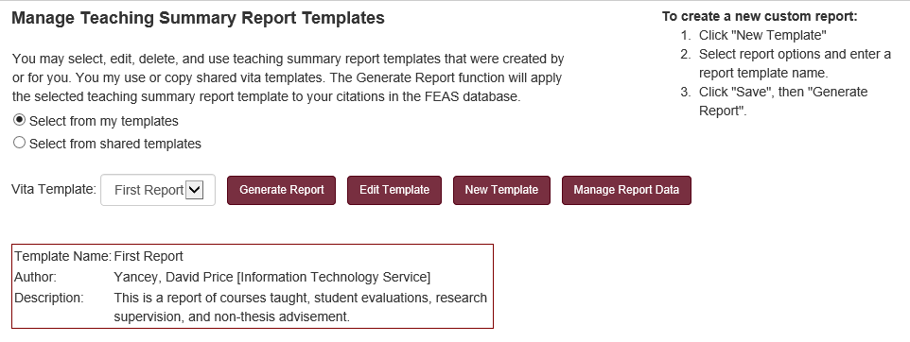

The following form is displayed when editing or creating a new teaching summary template.

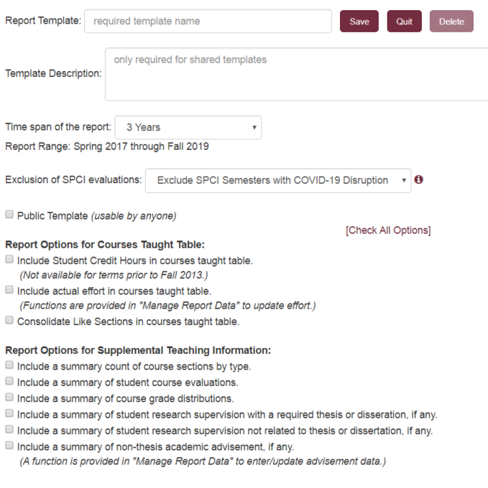

Depending on the reporting options selected, the custom teaching summary report may contain five sections of information:

- Summary of Courses Taught.
The contents of this table may be altered by the report options and the report date range. Course information is obtained from courses downloaded from Student Central (which may be manually modified if necessary). If no report options are selected, this is the only table included in the report.
- Summary Count of Course Sections.
This is a summary count of the selected course sections categorized by course type. The various course types are described below in the discussion of the “Review/Edit Downloaded Courses” section.
- Summary of SPCI Course Evaluations.
Course evaluation information as collected and provided by the Office of Distance Learning. This is a summary of overall instructor evaluations, generally referred to as question 13. Course evaluations with fewer than 5 respondents are not displayed. Semesters disrupted by COVID-19 may be excluded from the report, dependent on the SPCI display option selected.
- Course Grade Distribution.
A distribution of grades by course. Grades with a plus/minus are consolidated to the letter grade. Course sections are combined if that option was selected for the courses taught table.
- Summary of Student Research Supervision with a Required Thesis or Dissertation.
This is a summary count of doctoral, masters, and bachelors committees taken from the teaching section of the CV. These are intended to count research supervision with a required thesis or dissertation. This section will not be displayed if no data is found in this CV category.
- Summary of Student Research Supervision Not a Part of a Thesis or Dissertation.
This is a summary count of doctoral, masters, and bachelor students that were cited in the “Supervision of Student Research Not Related to Thesis or Dissertation” category of the CV. This section will not be displayed if no data is found in this CV category.
- Summary of Non-Thesis and Non-Dissertation Academic Advisees.
This is count of academic advisees by year as specifically entered for this report. This information is entered using the “Review/Edit Non-Thesis Academic Advisement” function described below. This section will not be displayed if no data is found for the reported period.

The report may span a selected number of years, or a custom reporting interval may be selected. In this case, a specific range of semesters may be chosen for the report. If desired, this range could be larger than 3 years.

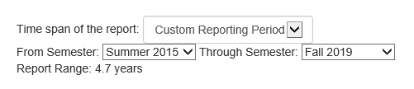

Manage Report Data

The "Manage Report Data" button is displayed on the report selection dialog; when clicked, it will present a menu of functions that manage data used in the teaching summary reports. The menu is illustrated below.

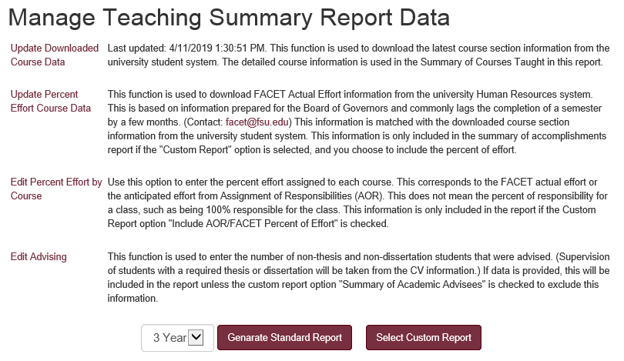

Functions include the download of updated course data from Student Central and update FACET percent effort for courses. The Edit Percent Effort by Course presents a table of courses in which the percent effort may be reviewed or updated. This information is automatically updated by the “Update Percent Effort Course Data”. Changes may be made here for purposes of FEAS reporting, but these changes will not update the FACET information source.

The Edit Advising table references the same data entered for the Summary of Accomplishments report. In this report, the non-thesis advising numbers are limited to the selected reporting period.

5.3 Grade Distribution Summary Reports

Grade Distribution Report

This report function reports grade distributions as obtained from Student Central system. This version of the report combines +/- grades; thus, B+, B, and B- would be reported as Bs. In this report, like sections are grouped with the same course number and section title. No information entered in the FEAS+ faculty CV is used in the preparation of the grade distribution report.

This report type offers options for a reporting span from one to five years. The particular semesters covered depend on the current date; the last semester reported will be the one prior to the current semester. A more explicit selection of semesters is available in the Teaching Summary Custom Report, where a grade distribution summary may be selected for the report.

Grade Distribution Report with +/- Grades

This report function reports grade distributions as obtained from Student Central system. All +/- grades are reported. In this report, like sections are not combined. No information entered in the FEAS+ faculty CV is used in the preparation of the grade distribution report.

5.4 Research Summary Reports

Research Summary Report

The basic research summary report provides a summary count of citations and citation contributors by citation category and by year. Citations with a status of Accepted, Contracted, Pending, and Submitted are excluded from this count. Each research summary report displays the "Manage Report Data" button on the report selection dialog, which is described below. Among other things, the manage report data function includes an option to update the tags which identify the contributor type applied to research citations.

This report type offers options for a reporting span from one to three years. The one year report will cover a calendar year (Spring through Fall). The particular semesters covered in the two and three year report depend on the current date; the last semester reported will be the one prior to the current semester. A more explicit selection of semesters is available in the Research Summary Custom Report.

Research Summary - Custom Report

The research summary custom report displays any available research summary report templates. Once a template is selected by clicking the associated radio button, the "Generate Report" button is displayed; click that button to generate a report using the report options specified for that template.

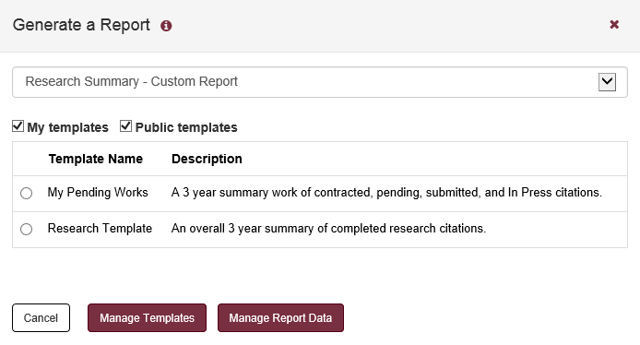

Click the "Manage Templates" button to edit or create new teaching report templates. The following page is initially displayed.

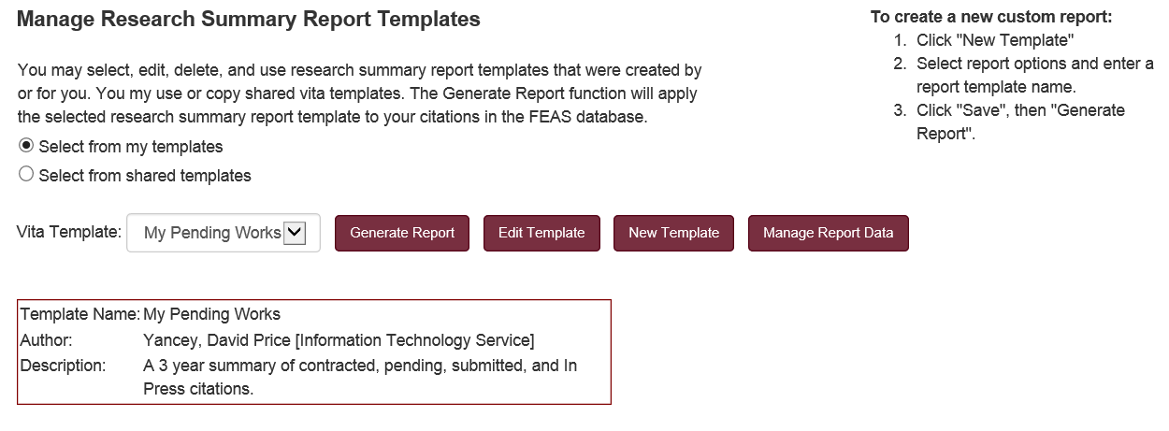

The following form is displayed when editing or creating a new research report template.

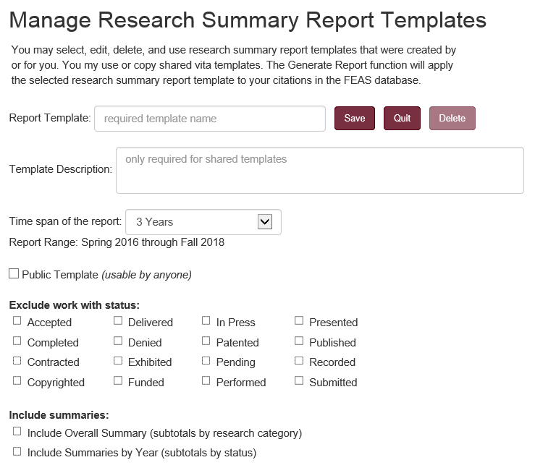

Among other things, the research summary report presents summary counts of the lead contributor for each research item included in the analysis. For example, a part of the display would include such information as:

Research and Original Creative Work  Summarized by Category | Total | Lead Contributor
Research and Original Creative Work  Summarized by Category | Total | Self | UG  Student | Mast  Student | Doc  Student | Prof  Student | Post Doc | Colleague
Invited Journal Articles Published | 2 |  | 1 |  |  |  |  | 1
Refereed Journal Articles In Press | 2 | 1 |  |  |  | 1
Refereed Journal Articles Published | 6 | 3 |  |  | 1 |  |  | 2
Nonrefereed Books Published | 2 | 2
Refereed Book Chapters In Press | 1 | 1
Refereed Book Chapters Published | 1 | 1
Nonrefereed Reports Published | 3 | 2 |  |  |  |  |  | 1
Publications Total | 17 | 10 | 1 |  | 1 | 1 |  | 4

In addition, the report includes information on the number of collaborations. In this report, collaborations are the count of authors on publications other than the faculty member him/herself.

Research and Original Creative Work  Summarized by Category | Number of Collaborations
Research and Original Creative Work  Summarized by Category | With UG  Student | With Mast  Student | With Doc  Student | With Prof  Student | With  Post Doc | With  Colleagues
Invited Journal Articles Published |  |  |  |  |  | 3
Refereed Journal Articles In Press | 1 | 1 | 1 | 1 |  | 1
Refereed Journal Articles Published | 3 |  | 4 |  | 1 | 7
Nonrefereed Books Published | 1 |  |  |  |  | 2
Refereed Book Chapters In Press |  |  |  |  |  | 1
Refereed Book Chapters Published | 1 | 1 | 1 | 1 | 1 | 1
Nonrefereed Reports Published | 1 | 1 | 1 | 1 | 1 | 6
Publications Total | 7 | 3 | 7 | 3 | 3 | 21

By default, the first name in the author list is assumed to be the lead contributor. In addition, the faculty member is identified from the list by matching the default name used for the faculty member. If the name is not matched, the name is assumed to be a colleague.

Research Citation Contributor Tagging

The "Manage Report Data" button is displayed on the report selection dialog; when clicked, it will present a menu of functions that manage data used in the report. This section describes the research citation tagging function.

When entering or editing citations in FEAS+, any of the contributors may be tagged as the lead and contributors may be identified as a student, post-doc, colleague, or a group. This information may be used in characterizing research collaboration.

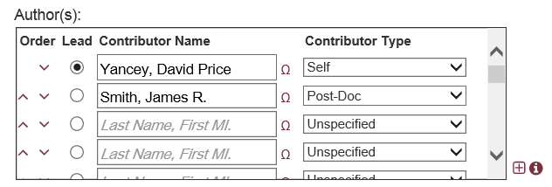

The contributor tagging function is provided as a means to review contributor tags and edit them. This provides a convenient mechanism to update all the contributor types at one time. The initial display for this function is illustrated below.

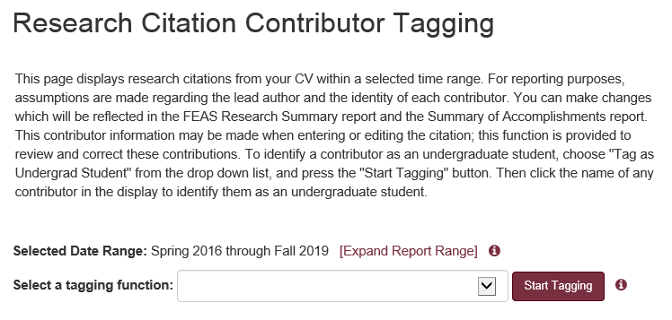

From the dropdown list, select a tagging function (e.g.: Tag as Doctoral Student) and click "Start Tagging". The “selected date range” specifies the range of citations included in the display. This range could be expanded, to include a wider range of citations for tagging.

The “Select a tagging function” is a drop down menu which is used to specify the type of tagging display presented. Options include:
- Tag as Faculty Member (Self)
- Tag as Colleague
- Tag as Undergrad Student
- Tag as Master's Student
- Tag as Doctoral Student
- Tag as Professional Student (e.g.: Law, Medicine)
- Tag as Post-Doc
- Tag as Group
- Tag as Lead Contributor

After making a tagging function selection, a list of citations are displayed. By clicking a contributor name, their tag will be changed accordingly.

The Tag Contributors function is like that provided in the Summary of Accomplishments Report. Contributors tagged in that report will appear here.

5.5 Summary of Accomplishment Reports

Summary of Accomplishments - Standard

The Summary of Accomplishments report combines elements from the Teaching Summary Report, the Research Summary Report, and the Custom CV for a 1 to 3 calendar year report. The standard version of this report includes a summary of courses taught, a summary of course sections, a summary of SPCI overall course evaluations, course grade distribution, summary of student supervision, summary of academic advisees, a summary of grant contract activity, a summary of research citation counts, as well as research and service citations within the reporting period. This is correspondent to the custom SOAR report with no data exclusions.

By default, the SPCI course evaluation summary will exclude semesters disrupted by COVID-19. An option is provided in the report selection dialog to override this behavior to include all semesters within the reporting period.

Each research summary report selection dialog displays the "Manage Report Data" button, which is described below. Among other things, the manage report data function includes options to review and update research citation contributor tags, refresh downloaded FSU course information, update academic advising, and provide supplemental information that may appear in the report.

Summary of Accomplishments - Custom Report

The summary of accomplishments custom report selection dialog displays any available SOAR templates. Once a template is selected by clicking the associated radio button, the "Generate Report" button is displayed; click that button to generate a report using the report options specified for that template.

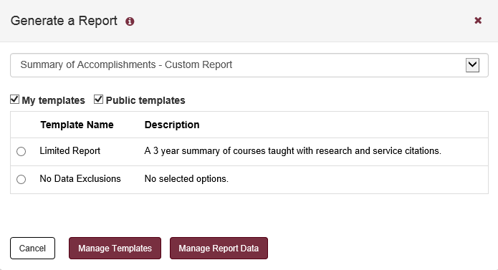

Click the "Manage Templates" button to edit or create new teaching report templates. The following page is initially displayed.

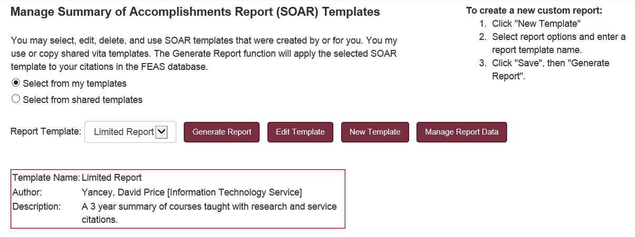

The following form is displayed when editing or creating a new summary of accomplishments report template.

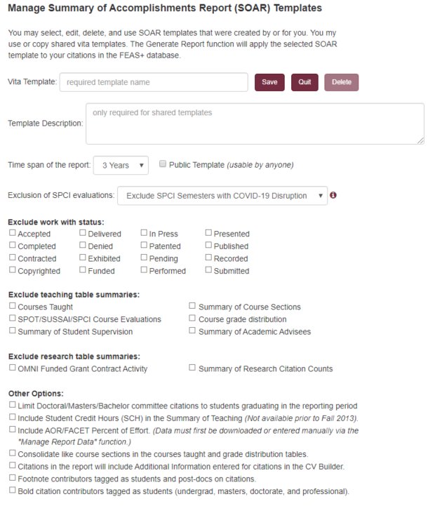

When a template is saved, it records the current checkbox settings for the custom report. If the “Public Template” is checked, then all FEAS+ users may select the template from the list of available templates. Otherwise, the template is private to the person that created the template. Only the person that created the template (or his/her delegate) may edit or delete the template.

Manage Report Data

The "Manage Report Data" button is displayed on the report selection dialog; when clicked, it will present a menu of functions that manage data used in the summary of accomplishment reports. The menu is illustrated below.

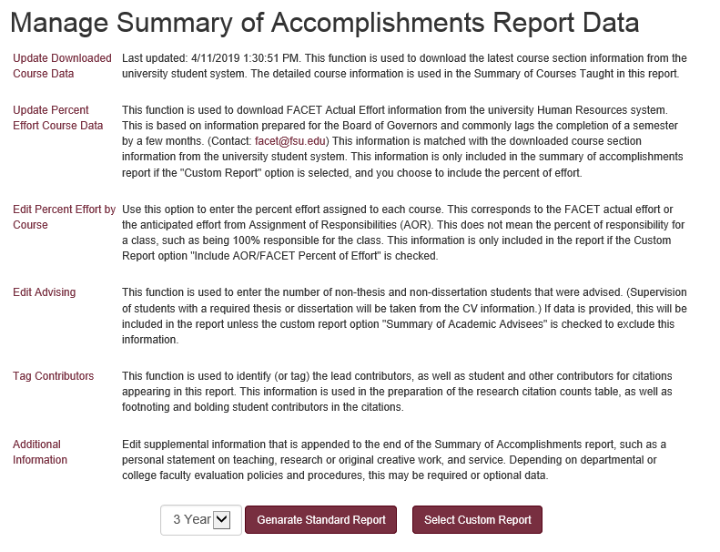

Functions include the download of updated course data from Student Central and update FACET percent effort for courses. The Edit Percent Effort by Course presents a table of courses in which the percent effort may be reviewed or updated. This information is automatically updated by the “Update Percent Effort Course Data”. Changes may be made here for purposes of FEAS reporting, but these changes will not update the FACET information source.

The Edit Advising table references the same data entered for the Teaching Summary report. In this report, the non-thesis advising numbers are limited to the selected reporting period. The Tag Contributors function is like that provided in the Research Summary Report. Contributors tagged in that report will appear here. Tagging may also be performed when entering or editing research citations.

The additional information function provides a free form textbox in which a summary statement may be entered which will appear at the end of the report. This statement is specific to the calendar year of the report and this information is not used in any other reports.

The Annual Summary of Accomplishments report includes:
- A custom version of the faculty member’s CV. In this variant, general information comes at the end and excludes address, professional experience, current membership, and expertise. In the teaching section, teaching summary tables replace the list of courses taught.
- Teaching Summary Tables. These tables are like those generated for the Teaching Summary Report.
- Research Summary Table. This table is like the annual summary table generated for the Research Summary Report. This table includes all research, regardless of status for the selected calendar year.
- Additional Information. This optional section is provided to append supplemental information to the report, such as a personal statement on teaching, research, and service.

5.6 Teaching Award Reports

Teaching Award Course Cover Sheet

This report function pulls student grade distribution information directly from the Student Central system and SPCI course evaluations which are managed by the Office of Distance Learning. This report merges grade distribution information with overall course evaluations. No information from the FEAS+ faculty CV is used in the preparation of these teaching award reports.

When this report type is selected from the report selection dialog, the second dropdown list will display a list of candidate courses within a three year period as well as an option for a summary of evaluations, as illustrated below.

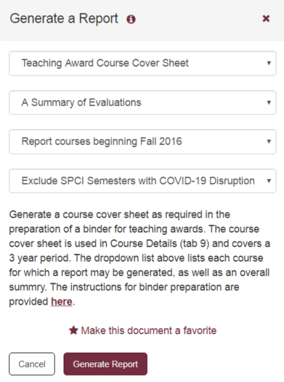

All courses within the reporting period are included in the list. Those courses without associated student evaluations are indicated as such. If no evaluations are available for the course, that information will be blank in the report.

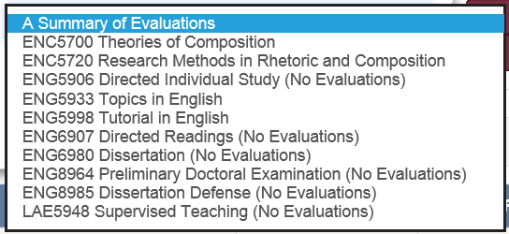

By default, the generated report will not include SPCI course evaluation summary data for semesters disrupted by COVID-19. An option is provided in the report selection dialog to override this behavior to include SPCI student evaluations for all semesters.

Distinguished Teaching Award Cover Sheet

This report is exactly like the Teaching Award Course Cover Sheet report, except in this case, the reporting period is 6 years. SPCI course evaluation data was first introduced at FSU in Spring 2013. Reporting for semesters prior to 2013 will include SPOT/SUSSAI student evaluation data.

5.7 Other Reports

Graduate Committees as Reported by GST

This report function pulls information directly from the Graduate Student Tracking (GST) system. This system is used by the Graduate School as the official record regarding graduate committees. GST provides functions for the Graduate School to check the composition of graduate committees to insure they follow university policies and links with manuscript clearance for the approval of theses and dissertations.
This report provides an option to report currently active committees or all graduate committees. Information is presented in a spreadsheet with columns for student name, academic plan, current program status, faculty committee role, student admit term, and graduation term.

Section 6: Export

When the Export button is clicked on the application home page, a dialog such as the following is presented.
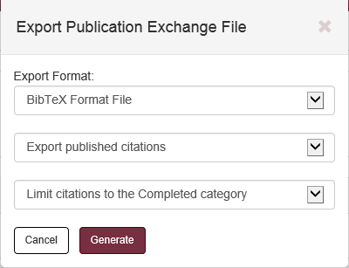

This dialog provides options to export publications into an EndNote, Refworks, BibTeX, or XML extract file formats. Two additional selections are available to limit the publication citations in the extract.

Limit by Citation Status:
- Export published citations. (Citations that are Submitted, In Press, Contracted, and Accepted are excluded.)
- Export all supported citations, including submitted.
Limit by Category:
- Limit citations to the Completed category.
- Include all citations. (Citations in Finish Later, Needs Review, and Imported are included.)

Not all types of FEAS publication citations are supported, and the level of support varies by file format. The following table summarizes the support for types of citations by export format.
Citation Type RefWorks EndNote XML BibTex
Journal Articles (Invited, Refereed, and Nonrefereed) ✔ ✔ ✔ ✔
Books (Invited, Refereed, and Nonrefereed) ✔ ✔ ✔ ✔
Edited Books ✔ ✔ ✔ -
Book Chapters (Invited, Refereed, and Nonrefereed) ✔ ✔ ✔ ✔
Proceedings (Refereed and Nonrefereed) ✔ ✔ ✔ ✔
Reports (Refereed and Nonrefereed) ✔ ✔ ✔ ✔
Papers at Conferences (Invited, Refereed, and Nonref) - ✔ ✔ -
Papers at Symposia (Invited, Refereed, and Nonrefereed) - ✔ ✔ -
Internet Web Site Development ✔ ✔ ✔ -
Computer Software Development ✔ ✔ ✔ -
Patented Inventions ✔ ✔ ✔ -
If a publication type is not supported (e.g., BibTeX does not support Edited Books), then the citation will not be included in the generated export file.

Section 7: Standard Menu Functions

The menu functions available from the menu dropdown list will vary depending on the user's roles within the FEAS+ application. This section describes those menu functions that are available to all faculty, without any special user roles.

7.1 Faculty Search

The initial faculty search display is illustrated below. A search may be conducted for a faculty name or all faculty in a department.

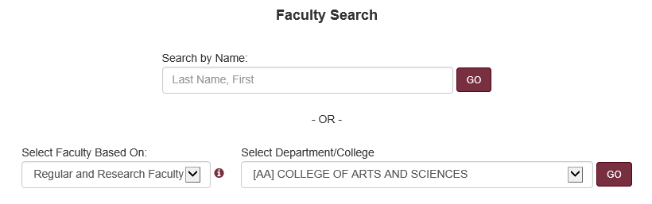
The search by name uses predictive text. Type a few letters, wait a second or two, and a selection list will appear. Click a name from the list (the name should appear in the text box) and click the GO button.

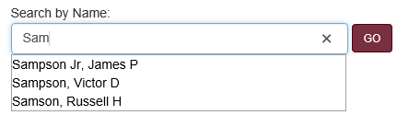

Alternatively, select a department or college from the dropdown list. By default, the faculty list includes regular and research faculty, but by choosing an option from the “Select Faculty Based On…” drop down list, faculty selection may be based on their tenure home, primary appointment, any appointment, or current and past faculty. Faculty that have multiple appointments will show up in each appropriate department list.

The population of employees loaded to the FEAS+ database is generally limited to those with jobcodes in the range 9001-9199 and have an active salaried appointment or joint-college courtesy appointment. Other FSU employees may also be included in the database by request. For example, some departments may wish to include their key adjuncts and provide vitae information for accreditation purposes.

A typical result from a departmental search is illustrated below.

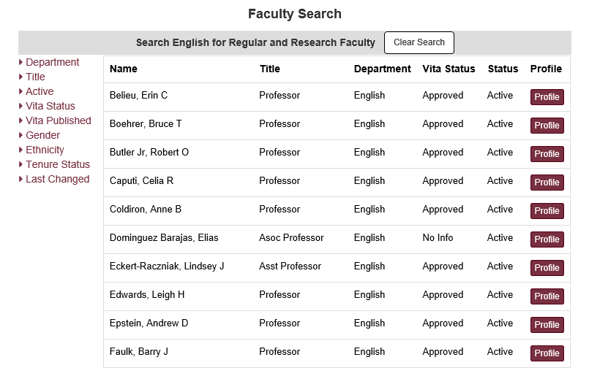

The information reported includes the faculty name, title, department, FEAS+ vita status, and employee status. Possible vita status values include:
- Approved -- all entries are completed.
- Needs Review -- entries made by a delegate on behalf of the faculty member must be accepted
- In Progress -- incomplete entries are found in Imported or Finish Later.
- No Info -- No entry information was found in FEAS+

The left side column provides options to filter the list. For example, the following selection would limit the display to teaching faculty.
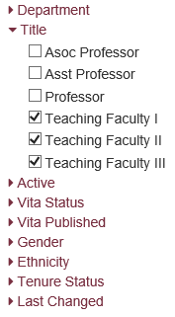
Click the "Profile" button to bring up information about the selected faculty member. The information displayed will vary depending on the FEAS+ roles granted to the user. Following is a typical display with no special FEAS+ roles. (See section 8.1 for advanced features.)

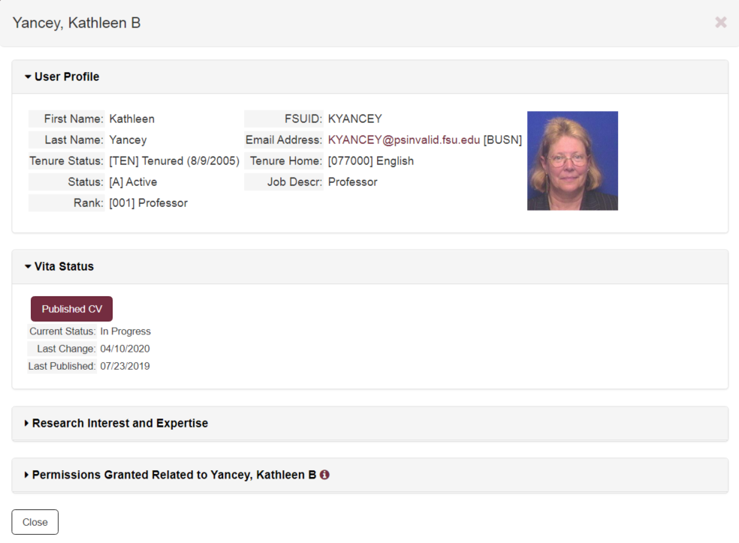

The "Published CV" button will only appear if the selected faculty member has a published vitae. If presented, the button will download or display that public CV.

The "Research Interest and Expertise" will provide a program of research statement as provided on the Research > Program of Research form for the faculty member. It will also include a summary of expertise provided on the Language Proficiency, Areas of Expertise, and International Affiliation forms.

The "Permissions Granted…" display will list all persons that have View and Delegate access to the selected faculty member's information in FEAS+. This could be used, for example, to identify delegates that could enter information on behalf of the faculty member.

7.2 Expertise Search

This function searches the FEAS+ database for faculty expertise. Expertise entries are found under the General tab on Add/Edit Entries; expertise involves language proficiency, areas of expertise, and international affiliations. The search term is not case sensitive.

Search results will display the number of citations per faculty member with options to view the detailed citation information, published CVs, and faculty profile information. The following illustrates a typical search result.

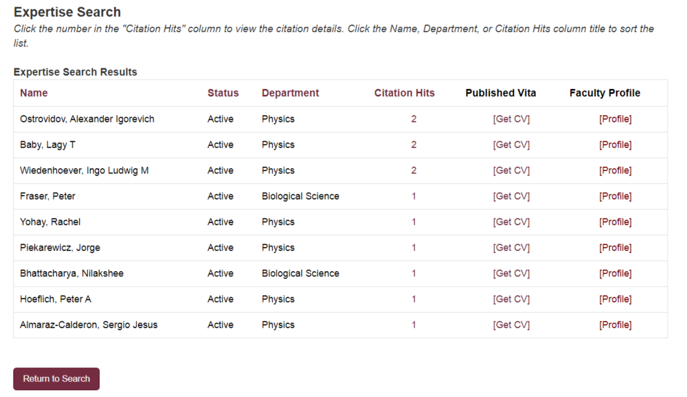

For each faculty member listed, the [Profile] link presents faculty summary information. This is the same profile as described in the previous section. If the faculty member has a published CV, a link is provided to display that document. The number of citation hits is a link which will display details regarding the entries that were matched as illustrated below.

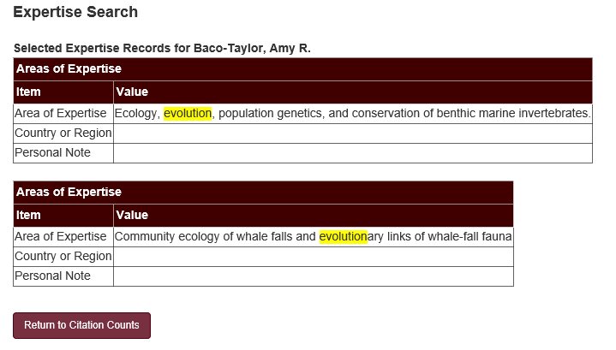

7.3 Preferences

Preferences can be used to alter the behavior of some reports and the creation of new entries. Functions are provided to change the default author name used on new entry forms, dates used for applying footnotes for the P&T CV, established the document format used when publishing a CV, and establishing an ORCID connection

7.3.1 Change Default Name

This function changes the default name used to pre-enter the faculty name as the author, presenter, performer, artist, and other like contributor field for new citations when using Add/Edit Entries. When editing CV entries, this name may be reformatted, changed, or appended to. This default name is simply meant to simplify the input for new entries.

The dialog illustrated below is presented when this function is selected from the Set Preferences menu. The [Restore System Default] function sets the default to the faculty member’s name as obtained from the FEAS+ directory.

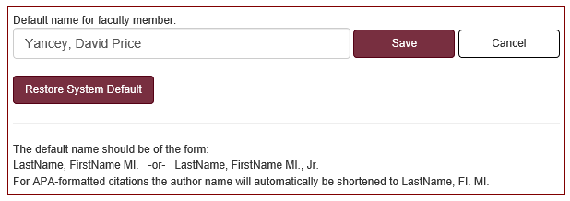

APA formatted citations abbreviate the author’s first and middle names (e.g.: “Yancey, D. P.”) If the name is spelled out, the first and middle names will be abbreviated as necessary for the generated CV.

7.3.2 Change Default Publish CV Options

This option provides faculty and delegates some control over the appearance of their CV information in the public website (see section 6). There are two parts to this preference item: managing the public CV file and managing the public expertise search.

Whenever a faculty CV is published, a copy of the generated CV will be posted to a public web site. This preference allows the user to identify the format of the CV that will be deposited on the public website. Options include:

- General CV (the default) - Short 5 Year CV
- Promotion and Tenure CV - QER CV
- Short 3 Year CV - Custom CV

The last option allows the faculty member to select a previously saved Custom CV template (see section 4.3) or a Custom CV template that has been flagged as “shared”. The following illustrates the dialog that would be presented for a faculty member that had not previously published their CV.

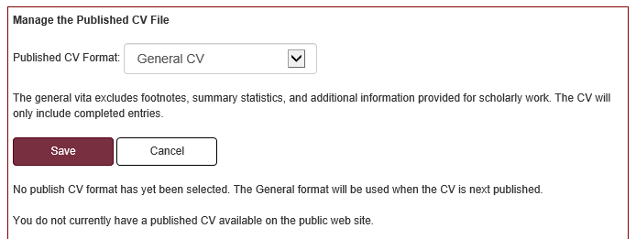

The second part of this preference option permits the user to regulate the use of expertise information in his/her CV for the public expertise search.

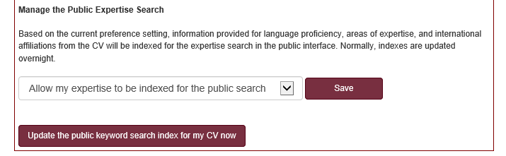

7.3.3 Override Start and Review Dates

The FSU starting date is used to footnote teaching, research, and service items as required by the promotion and tenure vita and the specialized faculty promotion vita to designate professional activities that occurred prior to employment at FSU. For the purposes of the CV prepared for P&T review, this is the date at which the faculty member began a tenure track appointment at FSU. By default, this date is the earliest start date for an entry in the Professional Experience category with the institution “Florida State University”.

The FSU P&T review date is used to footnote teaching, research, and service items to designate professional activities that occurred prior to the faculty member’s last promotion review. By default, this date is based on the latest Professional Experience entry with the institution “Florida State University” and with the “FSU Promotion” checkbox checked. This review date is assumed to be August of the year prior to the last promotion.

This function may be used to override these computed dates to ensure proper footnoting of entries in the P&T CV. The following figure illustrates the dialog that is displayed when this function is selected.

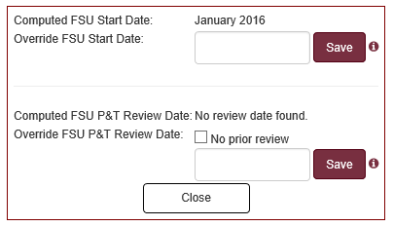

7.3.4 Connect your ORCID iD

ORCID (http://orcid.org) is an international not-for-profit organization created by the research community. They provide a persistent digital identifier (an ORCID iD) that distinguishes researchers and maintains a record that supports automatic links among professional activities. ORCID provides a registry of works (publications, conference presentations, etc.) that have been linked to the Orcid iD either by the faculty member or by a trusted organization. Each of these work records has a visibility setting: everyone, trusted parties, or only me.

This function is used register and connect a faculty member’s ORCID iD with FEAS. Once a connection is established, delegates and faculty may view the ORCID iD and may use that to import citations from the ORCID registry of works into FEAS (see section 3.3).

An ORCID iD may be connected to FEAS in one of three ways:

- Public. A faculty member’s ORCID iD may have been entered by an administrator into the FEAS database from other university data sources. This is treated as an un-authenticated identity and can be used to download public (everyone) works.
- Authenticated. Based on prompts, the researcher has authenticated their ORCID iD by logging into the ORCID system, but did not (or has not yet) approved FSU as a trusted organization. This can be used to download public (everyone) works.
- Trusted. Based on prompts, the researcher has authenticated and chosen to approve FSU as a trusted organization. This can be used to download works with a visibility setting of public (everyone) and trusted.

The “Connect your ORCID iD” function is used to review the status of the connection or to establish/upgrade that connection. If the faculty member does not already have an ORCID iD connection with FEAS, the following dialog is displayed.

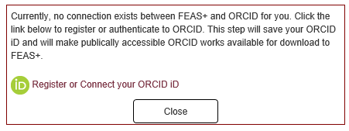

By clicking the link “Register or Connect your ORCID iD”, the user is taken to the ORCID sign-in page. The user must register for a new ORCID account, or sign-in to an existing ORCID account. Once the sign-in is completed, the user is returned to the FEAS+ Preferences page with a dialog such as the follows.

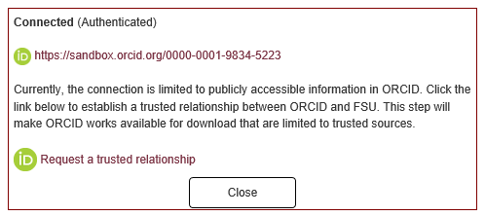

At this point, the ORCID iD is considered authenticated, but has not established a trusted relationship. In order to establish a trusted relationship, click the “Request a trusted relationship” link. The user would not be required to login to ORCID again, but would be asked if FSU could be trusted.

Only the FEAS faculty member may establish an authenticated or trusted relationship with ORCID. However, a FEAS delegate may use this function to review the status of the ORCID relationship. Once a relationship is established, this connection will be retained until the researcher chooses to revoke the trusted relationship with FSU within the ORCID system.

7.4 User Manuals
This menu function presents a menu of available FEAS+ documentation. New and updated documents may be added over time as may be developed. One special aspect of this page is that it does not require CAS authentication. This document menu page can be accessed directly from the following web address without a login.
https://feas.fsu.edu/ReferenceMenu.aspx

If this page is reached without going through a login, the dropdown menu will be limited. Click the FEAS+ Home icon to force a login after which other functions will become available.

Section 8: Advanced Menu Functions

The functions available from the FEAS+ menu dropdown list will vary depending on the user's roles within the FEAS+ application. This section describes those menu functions that are available to those with "View" or "Delegate" roles (see section 1.3).

By default, department chairs, deans, associate deans, and other university officials may use this system to view faculty information in their area. If the user does have rights to view other faculty CVs, functions described within this section will appear in the menu.

8.1 Faculty Search (Advanced Features)

If the user has been granted a View or Delegate role that encompasses the selected faculty member, then the information and functions displayed in the profile for the selected faculty member is expanded. Following is a display with both view and delegate roles.

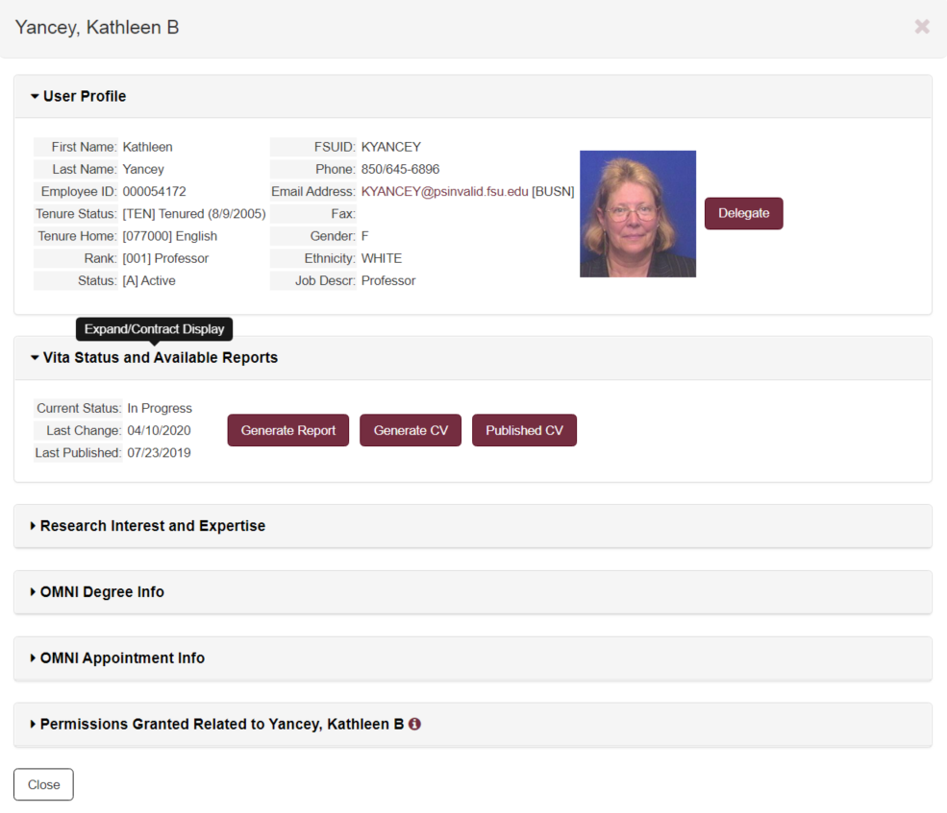

In this expanded display, the delegate button may be clicked in order to serve as a delegate for the selected faculty member. The Generate Report and Generate CV buttons will present options for generating documents; these functions are the same as those described in sections 4 and 5. OMNI degree info displays information downloaded to FEAS+ from OMNI; verified degrees are those that have been validated by the Office of Faculty Development and Advancement for purposes of accreditation. OMNI appointment information displays a summary of active and terminated FSU employee appointments.

8.2 Keyword Search

This function permits the user to search faculty entries contained in the database for a word or word fragment. Only those records for which the user has VIEW access will be included in the search. Thus, if the user has VIEW access for the college of engineering, only faculty with a “best appointment” within that college will be included in the search. The following image illustrates the Basic Search, which is the initial form displayed when requesting the keyword search.

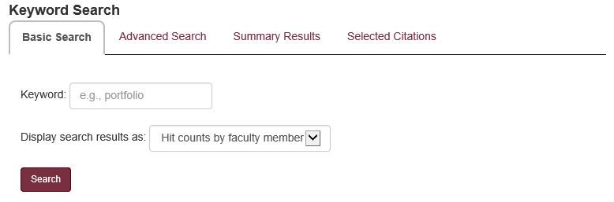

For a more nuanced search, the Advanced Search form may be used. Options are available to limit the faculty records searched by department, by faculty or vita status, by citation date, citation status, etc. The advanced search tab is illustrated below.

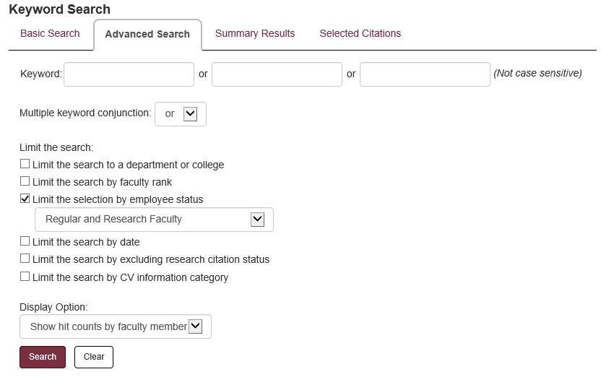

When an option is selected to limit the search, the display will expand to expose selection options. The figure below illustrates that the search is to be constrained to only search faculty expertise entries.

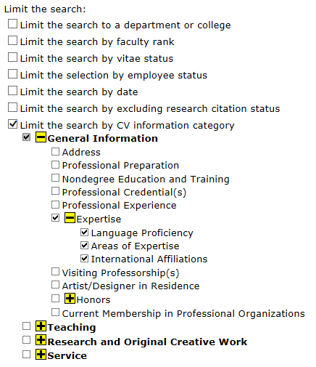

When a search is conducted, a summary of the entry hits is displayed as illustrated below.

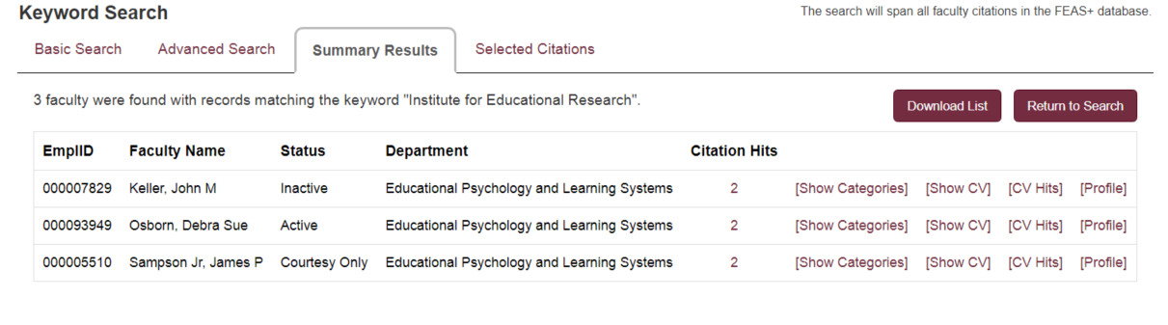

The [Profile] link will present the profile display as previously described in sections 7.1 and 8.1. The [Show CV] link will present a generated General CV. The [CV Hits] will generate a CV document with matched highlighted entries. The [Show Categories] link will present a breakdown of the entries by category for the faculty member. Matched entry details can be observed by clicking the number link in the Citation Hits column, as illustrated below.

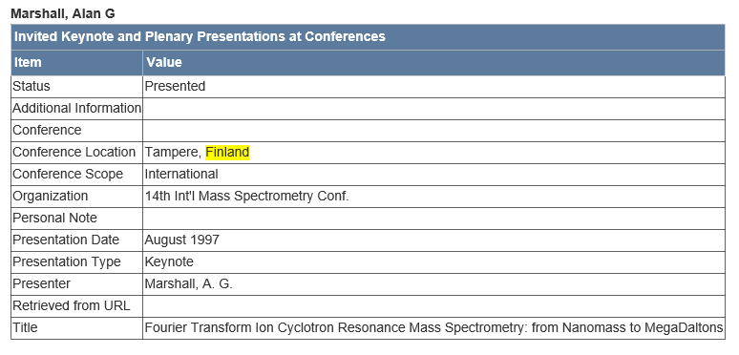

8.3 CV Item Reporting

This function is used to select entries from the database based on some selection criteria. Selected information may be presented as a web report, an Excel spreadsheet, a tab-delimited text file, or a formatted RTF file. In the latter case, the selected records are displayed as they would appear in a general vita.

When this function is first selected, the user is prompted to select from a list of reporting categories (e.g.: Honors and Awards, Journal Articles, Performances, Service to the Profession, etc.).

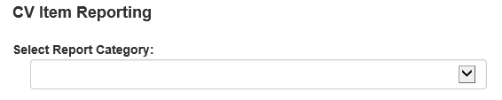

Some categories may expose a list of subcategories. Once a selection is made, a report selection form is presented as illustrated below.
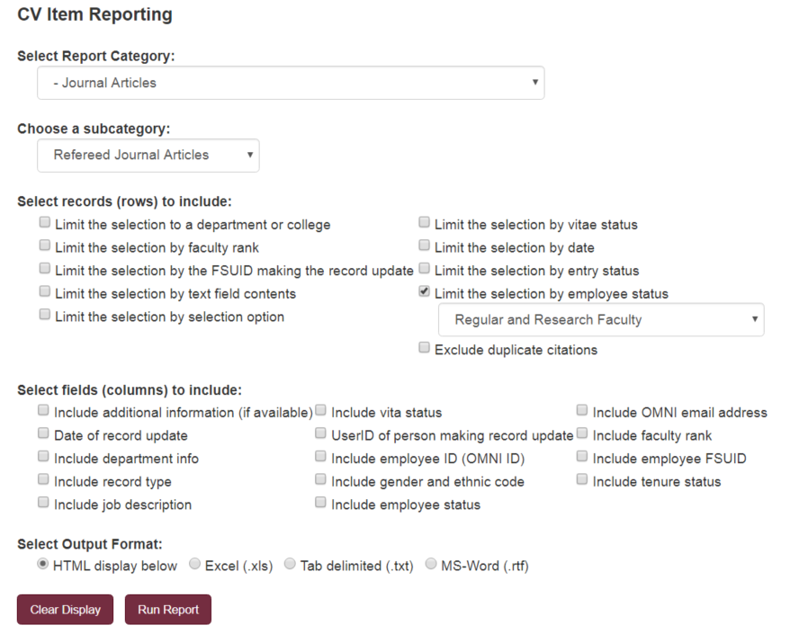

By checking any of the options to limit the selection of entries, a popup selection will be displayed to inquire as to the details of the constraint as illustrated below.

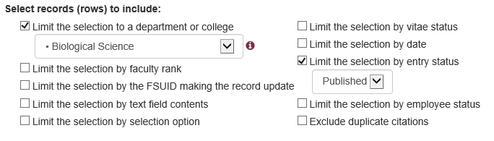

When the selected output format is HTML (the default), the result is displayed as a table with each column corresponding to a data field that is associated with the category of data selected for the report. The user may click any of the column titles to resort the list by that data field (e.g.: authors, publication date, title, journal, etc.)

8.4 Department Reports

This menu function generates reports that involve a group of faculty. When this is initially displayed, the user is tasked to select a department or college. By default, the faculty selected for the report includes regular and research faculty, but by choosing an option from the “Select Faculty Based On…” drop down list, faculty selection may be based on their tenure home, primary appointment, any appointment, or current and past faculty. (Similar selections may be made in Faculty Search, CV Item Reporting, and Keyword Search.)

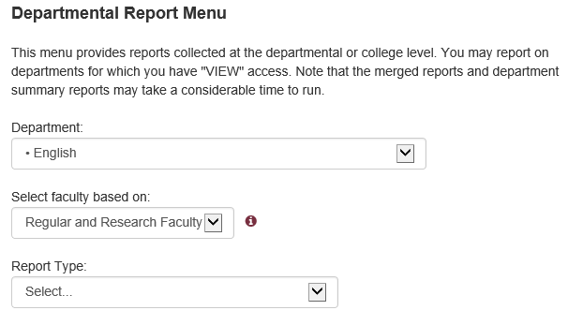

Depending on the report type selected, the menu may display additional options and button functions.

8.4.1 Department Vita Status Summary

When this report type is selected, a Generate Report button will be presented. That button will generate an Excel spreadsheet with information about faculty selected from the menu. Columns in the spreadsheet include the following.
- EmplID
- Name
- Department
- Tenure Status (e.g., Tenured, Not Tenure Track, Not Tenured on Track)
- Job Description (e.g., Professor, Teaching Faculty II)
- Vita Status (C = All Entries Completed, R = Needs Review, I = Incomplete items in Imported or Finish Later, X or blank = No Entries)
- Last Change Date
- Changed by (i.e., who made the last change)
- Published
- Publish Date (prior to August 2019, this would be the last finalization date)
- Email Address

8.4.2 Merged Departmental Report

This functions generates a given report or CV for every faculty member in the selected department or college, and merges them into one document. When this report type is selected, a submenu allows the user to select the type of report or CV that is created. The options include the following.
- Promotion and Tenure CV
- Specialized Faculty Promotion CV
- General CV
- Short CV (1 to 7 years)
- QER CV
- Custom CV
- SPCI Overall Evaluation Summary (1 to 7 years)
- SPCI Evaluation - 13 Questions (1 to 7 years)
- Teaching Summary Report (1 to 3 years)
- Teaching Summary Report with Effort (1 to 3 years)
- Extended Teaching Report (1 to 3 years)
- Teaching Summary Custom Report
- Grade Distribution Report (1 to 3 years)
- Grade Distribution Report with +/- Grades (1 to 3 years)
- Research Summary Report (1 to 3 years)
- Research Summary Custom Report
- Summary of Accomplishments Standard Report (1 to 3 years)
- Summary of Accomplishments Custom Report

8.4.3 Department Summary Report - Standard

This function generates a report with summary counts of CV entries that summarize faculty teaching, research, and service for the selected department or college. It also provides a summary of student collaboration. This standard report version includes the following information
- A list of faculty included in the report, with CV status and date of last update.
- A summary count of CV entries for doctoral, master's, and bachelor's supervisory committees.
- A summary count of CV entries with non-thesis research supervision by calendar year.
- A summary count of research and service CV entries by entry type and year.
- A summary count of contributors tagged as students by entry type and year.

For the standard report, entries with a status of "Accepted", "Submitted", or "Contracted" are excluded from the report. The standard reporting period is three years.

The following table illustrates a summary count of publication entries for a selected department. The number is the absolute count; the average is the count divided by the number of faculty incorporated in the report.

Publications
Category | 2017 |  | 2018 |  | 2019
Category | Number | Avg. | Number | Avg. | Number | Avg.
Invited Journal Articles | 4 | 0.1 | 3 | 0.1 | 1 | 0.0
Refereed Journal Articles | 4 | 0.1 | 11 | 0.2 | 5 | 0.1
Nonrefereed Journal Articles | 1 | 0.0 | 2 | 0.0
Invited Books | 1 | 0.0 | 1 | 0.0
Refereed Books | 5 | 0.1 | 4 | 0.1 | 1 | 0.0
Edited Books | 4 | 0.1 | 3 | 0.1 | 1 | 0.0
Refereed Monographs - Published Independently |  |  |  |  | 1 | 0.0
Invited Book Chapters | 10 | 0.2 | 5 | 0.1 | 1 | 0.0
Refereed Book Chapters | 22 | 0.5 | 19 | 0.4 | 8 | 0.2
Invited Encyclopedia Entries | 4 | 0.1 | 1 | 0.0
Refereed Encyclopedia Entries |  |  | 1 | 0.0
Invited Reviews - Published in Journal | 6 | 0.1 | 2 | 0.0 | 1 | 0.0
Refereed Reviews - Published in Journal | 3 | 0.1 | 3 | 0.1 | 1 | 0.0
Nonrefereed Reviews | 5 | 0.1
Invited Newsletter Articles | 2 | 0.0 |  |  | 1 | 0.0
Total | 71 | 1.5 | 55 | 1.1 | 21 | 0.4

8.4.4 Departmental Summary Report - Custom Report

When custom departmental summary report is selected, a list of available report templates is presented. The "Generate Report" button is initially hidden, but will be displayed when one of the radio buttons associated with a report template is selected. Templated may be viewed, edited, deleted or new ones created by clicking the "Manage Templates" button.

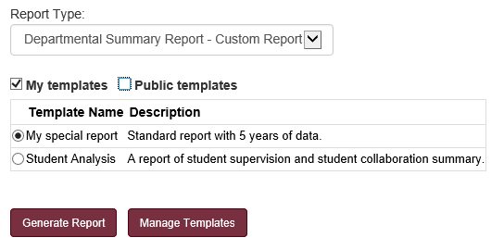

When "Manage Templates" is clicked, something like the following is initially displayed. The user may choose from shared templates or personal templates.

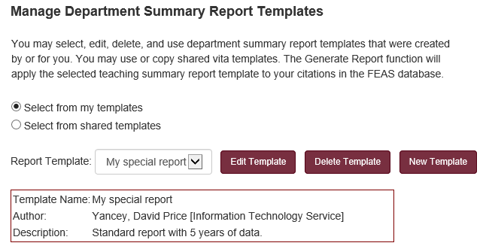

When a new template is selected, the options are initialized to correspond to a standard report. Those options may be changed, and if appropriate, a different number of years may be selected. The report may be customized to exclude certain categories of entries, remove or add exclusions based on entry status, and summary tables included or excluded. Templates can also be made public (shared) that can be used by others.

8.5 Delegate

This function is presented in menu only if the user has Delegate authority for one or more individuals, one or more departments, one or more colleges, or for the university. When this function is selected, the user will be presented with a selection menu as illustrated below. Faculty can be selected either by picking from a departmental list or by directly entering a name.

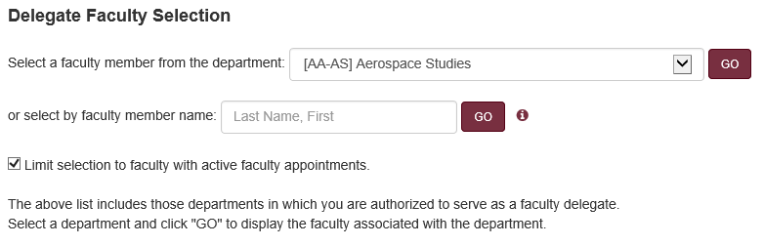

In the drop-down list, the department name is prefixed by the division (i.e., AA = Academic Affairs) and the college (i.e., AS = College of Arts and Sciences). Only those departments for which the user has access will be displayed.

After selecting a department from the drop-down menu and pressing the GO button, a list of faculty is displayed as illustrated below. This list includes all faculty that have been downloaded into the FEAS+ database and have an appointment or “tenure home” corresponds to the selected department.

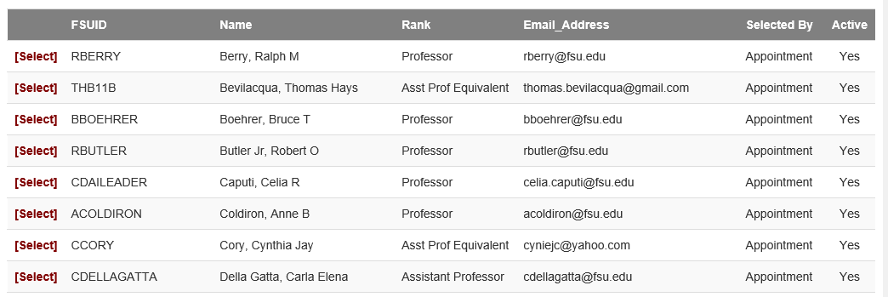

When a user clicks the [Select] link for a faculty member in the list, Add/Edit Entries display is brought up for that faculty member, and the user can enter information on his or her behalf.

An alternate method of selecting a faculty member is by directly entering a name. After entering a few characters in the name field, a drop down list will appear matching the characters typed from which the delegate can select a faculty name for data entry. Only those faculty to which the user has access will be presented. Select a name from the list and click the associated GO button.

Later, if the user selects Delegate from the menu, a display will be presented which allows the user to terminate serving as a delegate for the selected faculty member.

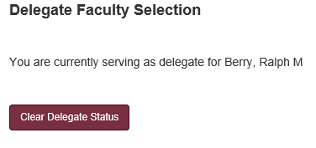

Section 9: Supplemental Documentation References

- FEAS+ Reference Documentation Menu
https://feas.fsu.edu/ReferenceMenu.aspx
- Frequently Asked Questions (requires login)
https://feas.fsu.edu/ReferenceFAQS.aspx
- Scientific Names, Expressions, and Foreign Accents in the CV Builder
https://feas.fsu.edu/docs/Text_Expressions.doc
- FEAS+ Faculty Reports
https://feas.fsu.edu/docs/FEAS_Reports.doc
- FEAS+ CVs
https://feas.fsu.edu/docs/FEAS_CVs.doc
- Importing from FSU Sources
https://feas.fsu.edu/docs/Importing_FSU_Sources.doc
- Importing from CSV Files
https://feas.fsu.edu/docs/Importing_CSV.doc
- Importing Citations from PubMed using RefWorks
https://feas.fsu.edu/docs/Importing_PubMed.doc
- Importing Citations from JSTOR using BibTeX
https://feas.fsu.edu/docs/Importing_JSTOR.doc
- Importing Citations to CV Builder from Web of Science using EndNote Web
https://feas.fsu.edu/docs/Importing_WebOfScience.doc
- Importing XML
https://feas.fsu.edu/docs/Importing_XML.doc
- Importing ORCID
https://feas.fsu.edu/docs/Importing_Orcid.doc
- Exporting Publications from FEAS+
https://feas.fsu.edu/docs/Exporting_Publications.doc
- FEAS Delegate Request Form
https://feas.fsu.edu/docs/Delegate_Request_Form.pdf

The login screen may be skipped if the user has already logged into another CAS (central authentication service) enabled university web application.
The user is considered an employee if he or she is identified as having an EMPLOYEE or FACULTY role within the university directory. (The system will also admit persons with the EMPLCOURTESY, RETIREE, and EMPLTERMED affiliations). This means they must be found in the OMNI Human Resources system.
At present, department chairs, associate deans, deans and other university officials are granted access to view faculty information in their area. Other requests by university officials may be accommodated.
Some citations, such as Courses Taught, will display the date as a semester, rather than month/year. By convention, month 1 = Spring, 6 = Summer, and 9 = Fall.
For example, this is found on "Areas of Expertise", "Editor for Nonrefereed Journals", "FSU University Service" and other forms.
The PURL is a permanent URL that links to an item in FSU’s digital repository.
Citations that occurred before employment at FSU and before promotion review are flagged. The date of a citation may be indicated by year, or more precisely by month and year. If a citation is dated only by year, then an “optimistic rule” is used. In this case, citations that occurred in the same year as the review date are not flagged for exclusion from consideration. In order to more precisely articulate which citations should be flagged in the P&T CV, take care to include the month of the citation in the FEAS citation entry.
P&T binders for promotion from Assistant to Associate are prepared far in advance of the actual promotion. Accordingly, a special accommodation is made for those faculty preparing a P&T CV for a promotion to Full Professor. By default, the date used for flagging citations prior to promotion is August of the year prior to promotion. In this way, citations that were not included in the previous promotion binder may be included in the faculty member’s binder for promotion to Full Professor. If this date calculation is deemed inappropriate, a corrected review date may be entered in Preferences > Override Start and Review Dates.
The intent is to ensure a greater currency of data from a reliable source to support the QER review process.
At the time of this writing, an older MLA style is used. It is intended that the MLA style will be updated in a future update for FEAS+.
The Office of Faculty Development and Advancement (FDA) has ordered special handling of SPCI student evaluation reports. By default, semesters that were disrupted by COVID-19 are excluded from SPCI student evaluation reports. At the time of this writing, those semesters include Spring and Summer 2020.
Course types include Class Lecture, Laboratory, Directed Individual Study, Graduate Dissertation, Supervised Teaching, Discussion, Graduate Thesis, etc.
Course enrollment information in Student Central prior to Fall 2013 makes it impossible to accurately compute grade distributions for some course sections (this is when the FSU student system was migrated from a home-grown system to the PeopleSoft system). Prior to Fall 2013, legacy grade data is used for this reporting.
The College of Law commonly uses number grades in lieu of letter grades. In this case, grade consolidation will be based on a range, 91--100, 81--90, etc.
Depending on the type of form, this would apply to a list of artists, performers, presenters, exhibitors, and other such lists as may be appropriate in the context.
The research summary does not consider citations from the category of “Reviews of My Research and Original Creative Work by Other Authors”.
Regular and Research faculty include all those with an appointment in the selected department or college with a status of A (active), L (leave of absence), or P (leave with pay), have a jobcode in the range 9001 – 9199 (i.e. professor, instructor, lecturer, eminent scholar, university school professor, associate in, research associate, university librarian, etc.), and have an employee class code of 10 (faculty research) or 16 (regular). [This would not include courtesy, USPS, OPS, visiting, adjunct, joint college, and clinical appointments.]
When working as a delegate, the faculty name entered here applies to the selected faculty member and is saved for him/her.
When working as a delegate, the public CV options selected here apply to the selected faculty member and are saved for him/her.
The best appointment is commonly the salaried appointment or where the predominance of effort is performed.
Regular and Research faculty include all those with an appointment in the selected department or college with a status of A (active), L (leave of absence), or P (leave with pay), have a jobcode in the range 9001 – 9199 (i.e. professor, instructor, lecturer, eminent scholar, university school professor, associate in, research associate, university librarian, etc.), and have an employee class code of 10 (faculty research) or 16 (regular). [This would not include courtesy, USPS, OPS, visiting, adjunct, joint college, and clinical appointments.]

